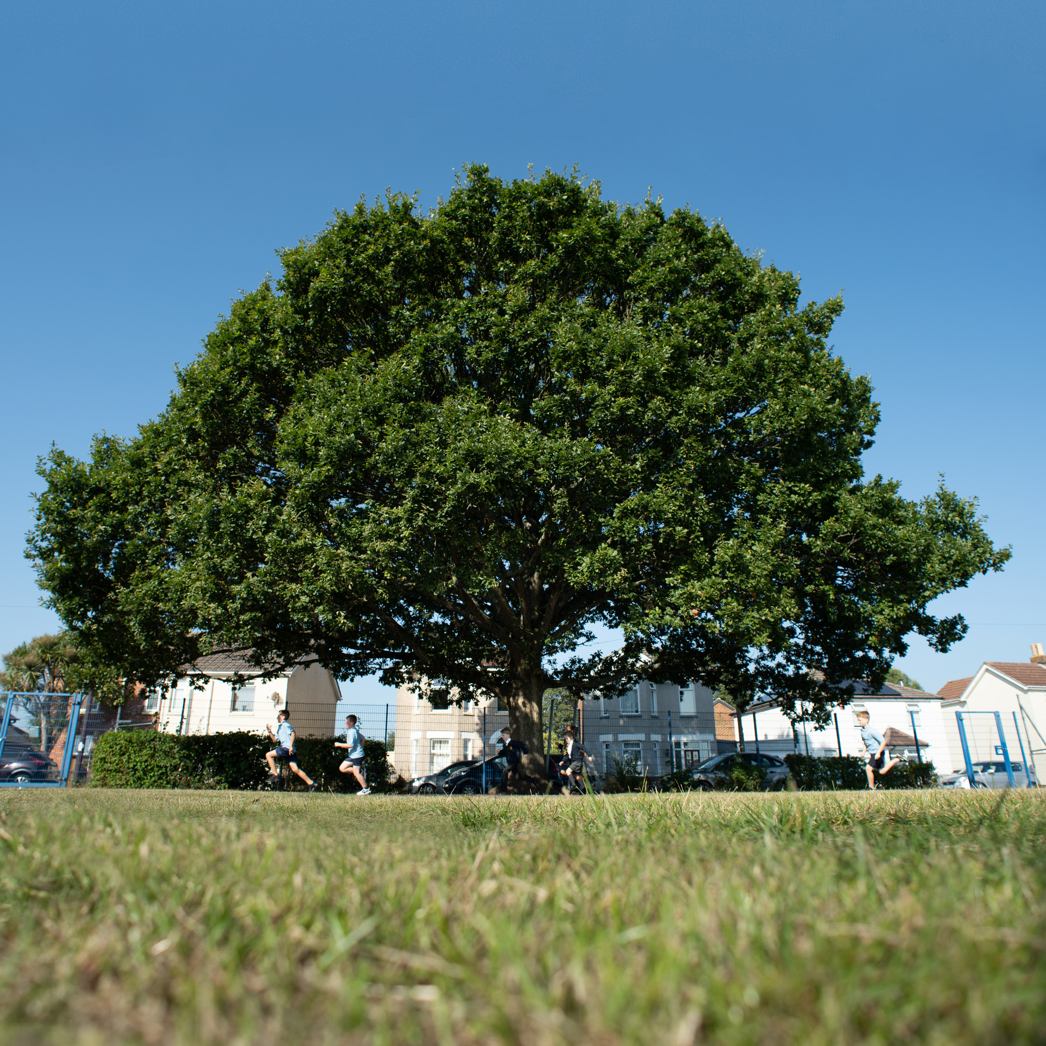
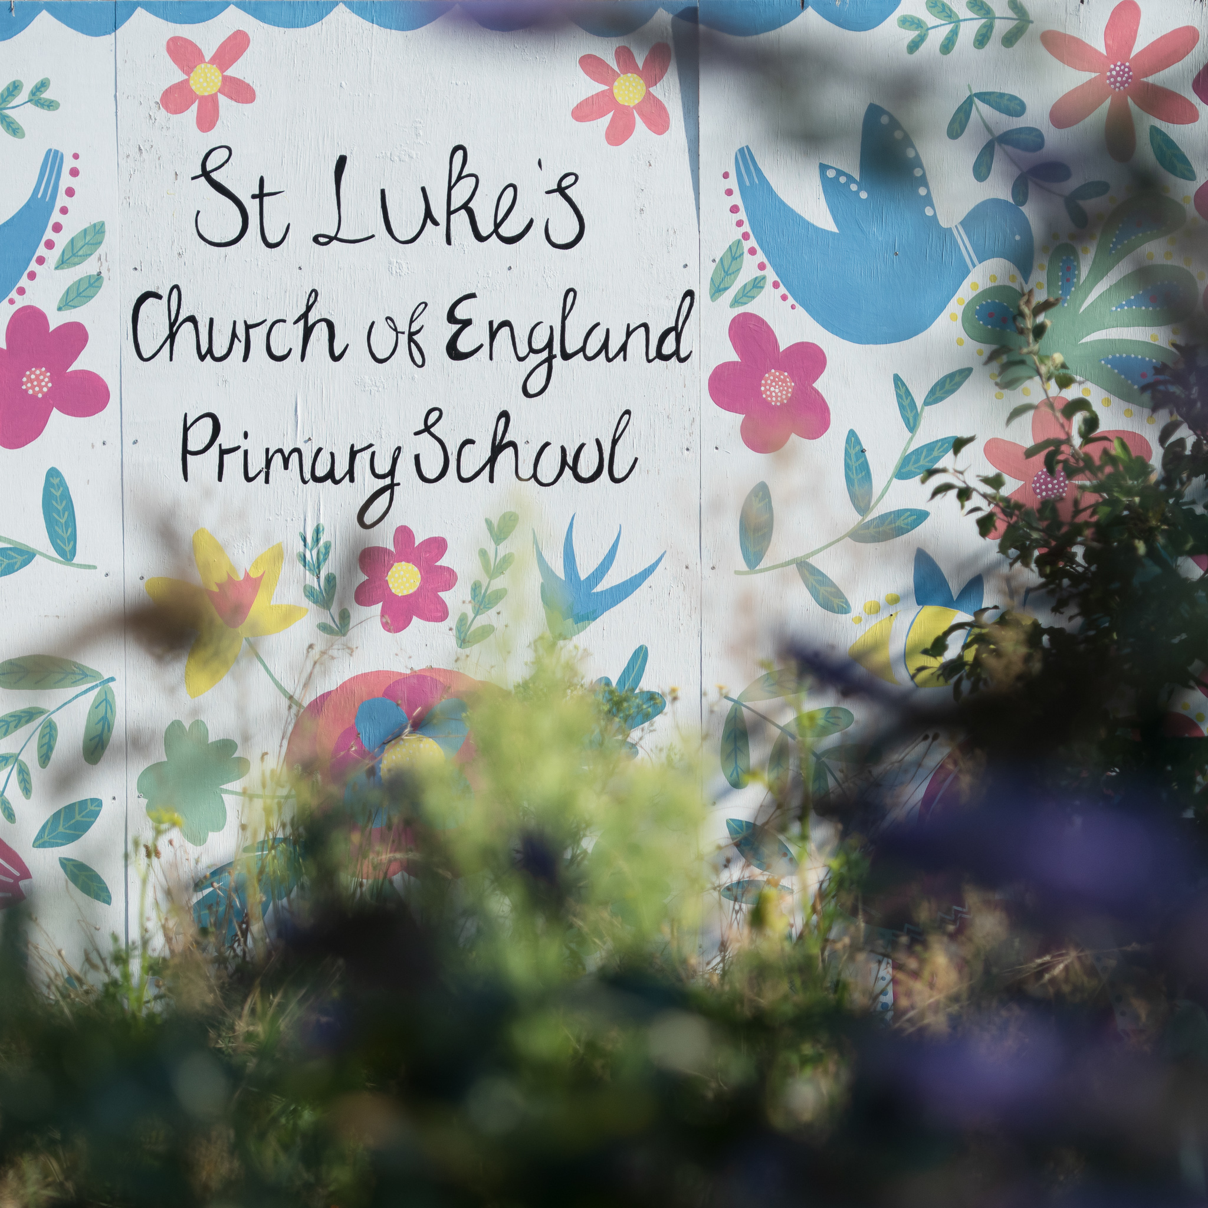


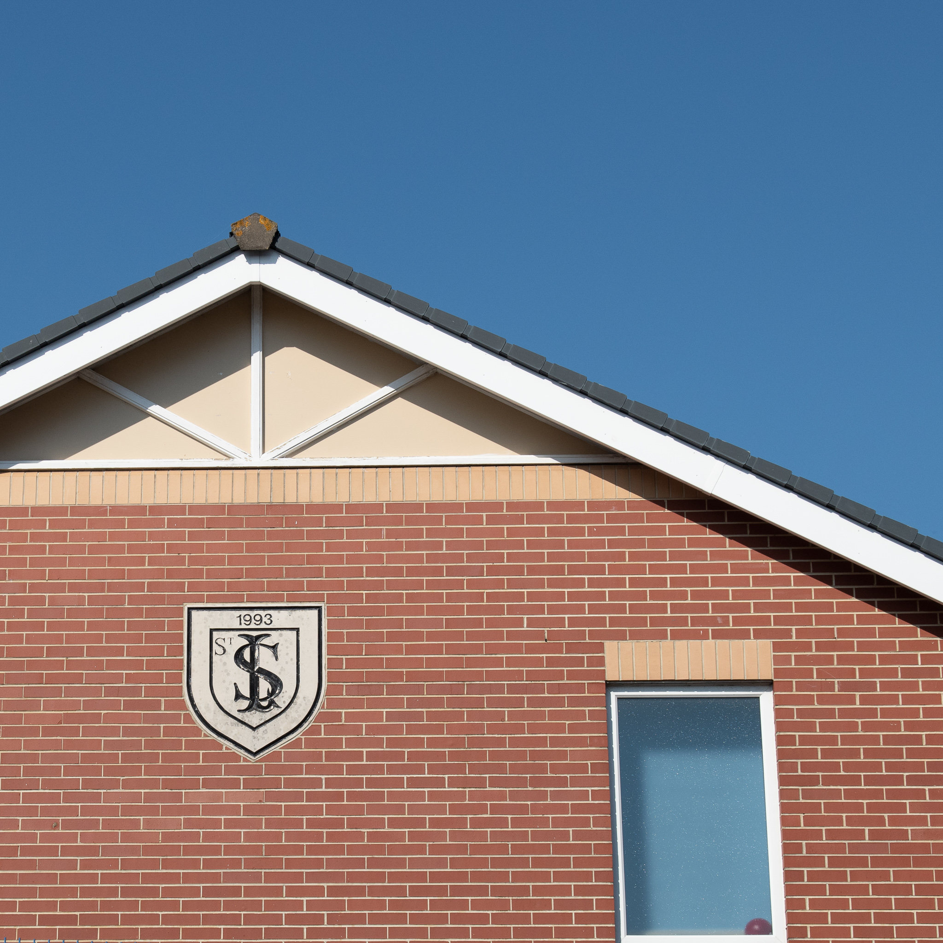
St Luke's
Staff Handbook
April 2025

St Luke's
PUPIL HANDBOOK
JULY 2025



Dear St Luke’s pupils,
We welcome you to our amazing school. Here we do the best to our ability in helping you to accomplish your goals. And with care from our student and teachers, you can feel like you are one amazing student. We are very proud to have you here wit us and we are going to make you feel like home. Please enjoy you time here as one of our pupils.
Yours Sincerely,

Grace, Bertie, Phoebe, Louis, Harris and Annabelle.

Contents:
Jobs,
Uniform,
Sports and clubs,
Trips,
Church,
Terms and half terms,
Lessons,
Anti-bullying,
Thank you,
Jobs
You may be wondering how you get a job (such as a council). There are many jobs such as: Head student, Deputy head, Anti-bulling ambassador, Sports ambassador, Worship leader, Eco leader, School council and Librarian. The Head students have meetings and plan things for the school. Anti-bulling ambassadors stop people being unkind so people don’t feel afraid. Sports ambassadors, clean up the playground and go to the infants to entertain the pupils with sporting activities. Worship leaders set up the worship and when done, they pack it away too. Eco council, they protect the environment (like the pond) and do litter picks. School council will help make school improvements such as new activities and help people to improv school standards. You can sign-up at the start of the year or, if the person laves with the job, your ca takes it (if they are willing to give the responsibility to you).

Uniform

There are two types of uniforms you wear in the school week. One of your uniform is smart and neat (the one you wear 3 times a week). The second one is when you are doing sports and PE. For PE, you wear a blue shirt, shorts or joggers, and trainers. For school uniform, you wear a white shirt, cardigan or jumper, skirt, shorts or trousers a tie, badges (if you have a responsibility) and school shoes.

Sports and Clubs

At St Luke’s, we have lots of clubs and after school activities such as: year 5/6 girls football, year 5/6 boys football , year 3/4 girls football , art, music (Rock steady),netball, drums, Lego, gardening and fitness. Feel free to sign up for any class you are willing to. Please make sure you pay for rock steady and be ready to start jamming!

Trips

At St Lukes, you have the opportunity of a lifetime in the school to get to go on amazing adventures. There are many activities on the trip and many sites to see. The trips you can try are: Egyptian museum;
Stone age site; science museum; Marwell zoo; Bovington tank museum; PGL; and many more amazing places you get to go to!

Church
Every term we have a church service at the church of St Lukes Church of Winton. For special events that happen throughout the year that happened to Jesus. We go to the church to learn about Jesus and the special celebrations around the world, such as harvest and spring. We have many chances around the church to help with the assembly such as reading prayers and reading lines to the people listening to the church service. We, as St Luke’s, want you to celebrate what Jesus did for us and how he help us.

Terms and Half Terms

At St Luke’s we want to take a break from all the amazing work we do here. So, we have a break called half term. A half term is normally held for a week so you can relax before you go back to school. A two-week term is normally for a holiday such as Easter or Christmas. We also have a six week break at the end of the year so it separates you from school before you move up a year.

Lessons

You might be wondering what you will learn here at St like. We provide many interesting lessons for you to enjoy and to participate in. The following lessons are below: Maths, English, History, Science, RE, PSHE, PE, Geography, Music, Art, Computing, DT, spelling and Reading.
These lessons will help you to become a great pupil here at St Luke’s.
Anti-Bullying
Bullying happens when somebody isn’t kind and does non positive behaviour toward you or someone else several times on purpose. We have Anti-Bullying ambassadors to go and help people who experience this. Bullying is not tolerated here at St Luke’s so we will be on the dot to stop bullying here.

Thank You
Thank you for bringing your child here to St Luke’s.+
And we also would like to thank you for giving of your time to read this letter that we have made so your child feels welcome to the school.

Yours sincerely,

Grace, Bertie, Phoebe, Louis, Annabelle and Harris

