Enquiry Questions
How have hospitals changed? | What do plants need to survive? |  | What source gives me the best evidence?
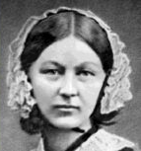    Key Vocabulary:  Timeline, significant, source, influence  Co-operation, trust,  Germination, survival |  | As historians we will learn to compare the past and present using sources as evidence-based research. Understanding what a source is and how useful a source is will be key to our learning.  In design and technology, we will be using our knowledge of materials to make a chair for Goldilocks by exploring joining and strengthening techniques. We will then evaluate the effectiveness of our products.  In PSHE, we will learn about family relationships, roles and responsibilities in a family and the importance of co-operation, appreciation and trust.  As scientists, we will explore the growth of plants and what plants need to survive.

English
Our main focus this term will be a character description and our writing will be based on the book Gorilla by Anthony Browne.
Word structure
To use the suffixes -ful and -less to form adjectives.
To use the suffixes -ness and -ment (to form nouns).
To know ‘because’ as a causal subordinating conjunction.
To use ‘or’ to join a clause to a word, phrase or another clause, when ideas are different or a choice.
Sentence structure
To write sentences using ‘if’ to join clauses.
To know ‘because’ as a causal subordinating conjunction.
Punctuation
To know that when a name ends in ‘s’, just the apostrophe is added.
To use apostrophes for contractions.

To use ‘or’ to join a clause to a word, phrase or another clause, when ideas are different or a choice.

Key Vocabulary

Maths
Fractions
We will look at different problems solving using fractions.
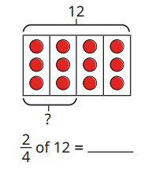
Addition and Subtraction
We are using our knowledge of exchanging and borrowing to work out different problems.
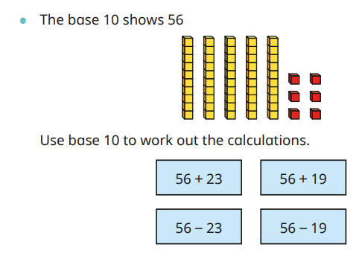
Statistics
Children will use and block diagrams, pictograms and tally charts. They will then use their knowledge to solve problems.


