Enquiry Questions
How is a coastal town like Poole different from other places? | How can we identify plants we see in gardens and in the wild? |  | Who is God to the Jews?
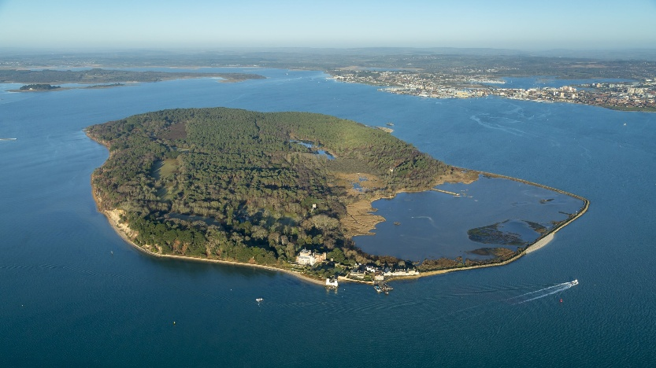  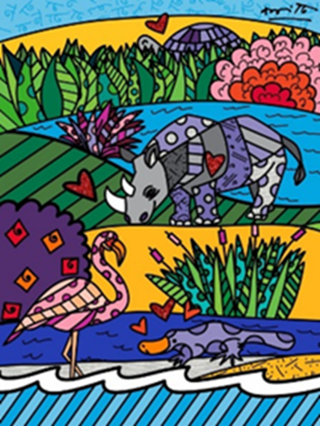  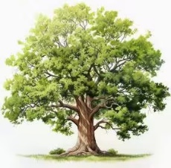  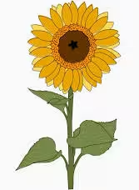  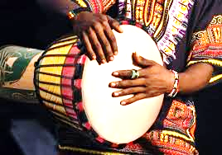  Key Vocabulary:  North, South, East, West, aerial map, evergreen, deciduous, attack, defend, pass, print, pattern, beat, rhythm, pulse, djembe |  | In geography, the children will be learning about towns, cities, and coastal features. They will learn that Poole has a large natural harbour and an important port, where ships stop to load and unload goods. The children will find out what a harbour is and understand that it is a sheltered place where ships can travel in from the sea to reach the land. They will also learn that there are often cliffs next to the sea along the coast. The children will explore what makes a town, including houses, offices, and shops, and learn that a city is usually bigger than a town. They will also learn that a factory is a place where things are made.  As scientists, we will be learning about plants. We will be observing how they grow and learn to name some parts of a plant. We will learn to identify and name some garden and wild plants in our local area. The children will find out about the difference between evergreen and deciduous trees.  As artists, the children will be learning about the artist Romero Britto. They will be exploring and making repeating patterns as well as creating their own ‘Britto’ style painting.  In PSHE, we will be looking at relationships that are important to us; with family, friends and people who help us.  As musicians, the children will be using Djembe drums to start learning African drumming. They will listen to a variety of music and practice different beats and rhythms on the drums.  In PE one lesson each week will focus on Invasion games, learning about the roles of attackers and defenders. The other lesson will focus on Net and Wall games, using rackets and learning about returning and passing a ball.  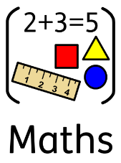  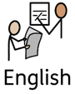  English  As writers, the children will be continuing to learn how to  write simple sentences, ensuring they are confident using  finger spaces, capital letters and full stops. We will be extending this by encouraging the children to use ‘and’ to add in additional words and detail to their sentences. The children will be learning about different types of words like singular and plural nouns and learning ‘rules’ to help spell them.  The first part of the half term our writing will be based on the book ‘It starts with a seed’ by Laura Knowles. We will be learning about how to build compound words and how it changes the meaning of a word.  We will be basing our writing of our experience at Brownsea Island. We will be introducing them to question marks and how we can use these to ask questions about Brownsea Island before we go. The children will produce their own recount of the trip will focus on writing in the past tense and using adjectives to describe the trip.  Key vocabulary: finger space, full stop, capital letter, story map, singular, plural, noun, verb, compound word, recount, past tense, questions, adjectives.  Key Vocabulary  Capital letters  Full stops  Finger space  Fred talk – children say and hear the sounds in a word  Non-fiction – a information text  Maths  As mathematicians, the children will start to look at  multiplication and division. A big focus of this will be  practicing counting forwards and backwards in 2s, 5s and 10s. The children will use this knowledge to help them recognise equal groups. They will also learn about what an array is and learn that doubling is two times the same number. They will then move onto making equal groups by grouping and sharing. They will use lots of practical resources to support them with this. In this block of learning, children will develop their understanding of halves and quarters. They will begin by recognising a half of a quantity, before moving on to finding a half of a quantity using practical resources and counting. Children will then learn to recognise a quarter of an object and practise finding a quarter of an object. As their confidence grows, they will progress to recognising and finding a quarter of a quantity. Throughout the unit, children will be supported to understand that halves and quarters must be equal parts of a whole.  Key Vocabulary  once, twice, three times, five times, multiply, multiply by, repeated addition, array, divide, divided by, left over

