Enquiry Questions
Why do some castles have moats? | Who are England’s royal family? |  | How different was life in the past?
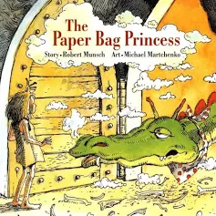  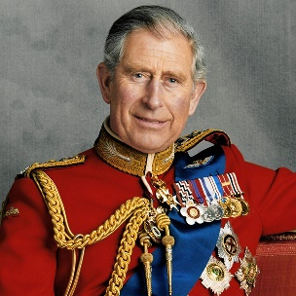  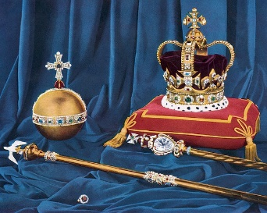  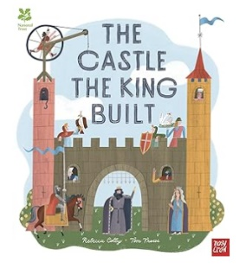  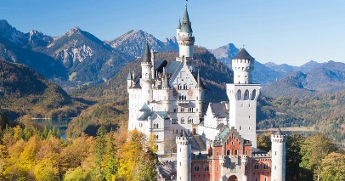  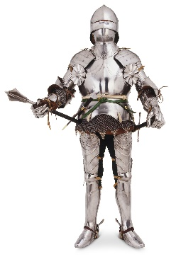  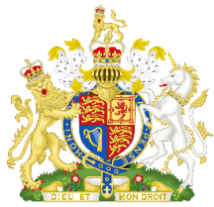  Key Vocabulary  history turrets royalty past present drawbridge  fairy tale banquet portrait moat kingdom |  | What is it all about?  We will learn about castles and the lives of those that occupy them. We will be looking at the differences and similarities between castles and their features now and in the past. We will be learning about kings and queens in stories and rhymes comparing those with real-life royalty and our own lives.  To end our topic we will be having a celebratory royal ball where the children are invited to come dressed as a king, queen, princess, jester dragon, etc. On this day we will have our stay and play. Adults fancy dress is encouraged! Ladybirds’ will be at 2pm on May 18th and Bumblebees’ will be at 2pm on May 19^{th.}  We are many amazing things… here are some examples:  …dancers, we will be learning about partner dancing and classical music.  …artists, we will be painting royal portraits.  …builders, we will be making 3D model castles.  …designers, we will be designing crowns and shields.  …historians, we will learn about the past.  …bakers, we will be making jam tarts.  …authors, we will be adapting different fairy tales.
Home Learning should build your skills and confidence. Challenge yourself to a selection of these tasks over the course of the topic. Please share what you have been up to on Tapestry.

Communication and Language Literacy Physical Development Mathematics Expressive Arts and Design Understanding the World Personal, Social and Emotional Development

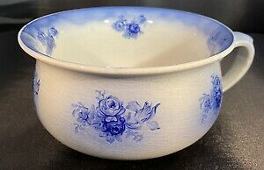  Investigate  What is this? | Share a book  Read a fairy tale. Can you talk about the characters? | Talk about what you learn  Watch a virtual castle tour online and discuss what you see. Can you learn any new vocabulary?
3D shapes  Go on a 3D shapes hunt around your home. How many can you name? Which ones would you find on a castle? (cylinder for a tower/cone for a turret) | Royal jewels  Look at jewellery you have at home. Do you notice any patterns? Can you name any of the special stones/materials? | Get crafty  Design and make a family coat of arms. What pictures could represent your family?
Knights’ tournament  Set up your own tournament in the garden just like the knights of the past | Family film time  Get together with your family, sit back and watch a film with a fairy tale theme. | Get making  Design and make part of your costume ready for the ball.

