Can a polar bear and penguin be friends?
What is different about life in other countries? | How do people celebrate special occasions around the world? |  | Does everyone speak English?
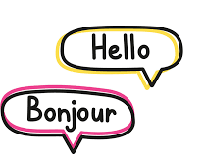  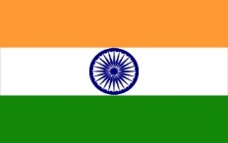  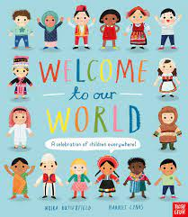      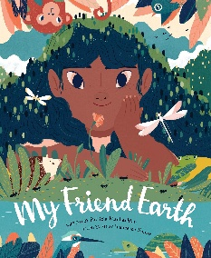  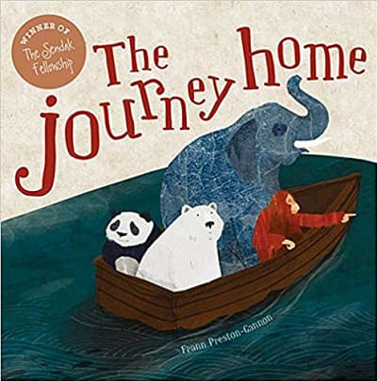  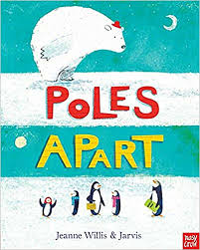  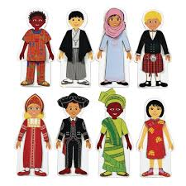  Key Vocabulary:  traditions culture celebrations communities  information festivals different same  language climate |  | What is it all about?  During this topic, we will be celebrating cultures, communities and religions from around the world, especially looking at our own backgrounds and those within our year group. We will be looking at the similarities and differences between countries and compare environments, homes, food, clothes, artefacts, traditions, music, dance and art. We will read stories and non-fiction books about our world as well as enjoying new experiences together.  If you have experience of another culture, be that food, clothing, lifestyle… please let us know if you would be happy to come in and share your knowledge with us at school.  We are many amazing things… here are some examples:  …dancers, we will be creating our own Bollywood dance.  …globe-trotters, we will learn about countries and cultures from around the world.  …linguists, we will be learning how to say hello in the languages from our home countries.  …curious, we will be finding out about our world and our place in it.  …respectful individuals, we will celebrate each other’s differences and explore different cultural traditions.  …responsible citizens, we will learn about how to respect and look after our immediate environment and the wider world.  …musicians, we will be discovering music from around the world.
Home Learning should build your skills and confidence. Challenge yourself to a selection of these tasks over the course of the topic. Please share what you have done on Tapestry.
Communication and Language Literacy Physical Development Mathematics Expressive Arts and Design Understanding the World Personal, Social and Emotional Development

Investigate  Look at a globe, name and research a different country. | Share a book  Read a book set in an unfamiliar location like the South Pole or the Jungle. | Family traditions  Talk about your own family and what makes you special and unique (i.e. is Friday night movie night?)
Capacity  Make bath time Maths time, by exploring containers and using vocabulary like full/empty/half-full… | Learn another language  How do you say Hello/Thank you/Goodbye? | Make a model  Can you make a model of a famous building from around the world?
Indian dancing  Put on some Indian music and show your family some typical bhangra dance moves. | Kindness  How can you show kindness to yourself and others? | Ball skills  Take a ball to the park  How many different ways can you pass a ball? i.e. kicking/throwing/rolling.

