
Positive Behaviour and Anti-Bullying Policy

Our Values: Compassion| Respect | Courage
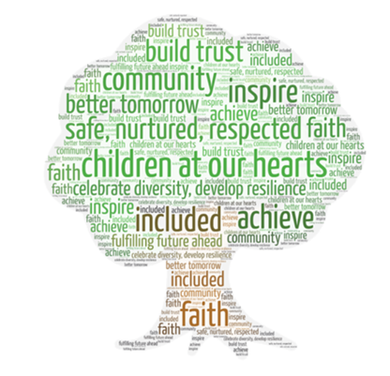
Policy Ratified: | September 2025
Review Date: | September 2026

Vision and Values
Through our core Christian values of Courage, Compassion and Respect, we aim to create an environment in which every child feels safe, secure and flourishes. Within a place of kindness, they will grow into individuals who believe in themselves and know that they are an important part of their community. Given outstanding opportunities for learning, they will have the drive to take on new challenges, the resilience to cope with life’s hurdles and know that they can learn from mistakes made. By fostering positive relationships, our children and staff will be empowered to be the best they can be.
At St Luke’s, we believe that secure and positive relationships, built through a culture of epistemic trust, will enable our children to thrive. Epistemic trust is the trust of knowledge’ that it is reliable and dependable. Therefore, for our children to flourish socially, academically and emotionally we prioritise positive relationships.

We recognise that good behaviour is recognised sincerely rather than just rewarded. Children are praised publicly and supported with behaviour with respect and consideration to their needs.

‘’When people talk about behaviour, they obsessively search for the instant solution. Some peddle magic dust or ‘behaviour systems’ that glisten yet quickly fade. Others relentlessly scream for a bigger stick to beat students down with. Both extremes harbour an irresistible idea that there is a short cut to changing behaviour. They sell the lie that you can provoke sustained behavioural change in others without doing much hard work yourself. The truth is that there is no alternative to the hard work: building relationships with those who would rather not, resetting expectations with those who trample them, being relentlessly positive and sustaining a poker face when confronted with challenging behaviour.’’
Paul Dix, Pivotal Education

Aim of the policy

- To create a culture of exceptionally good behaviour: for learning, for community, for life.
- To ensure that all learners are treated fairly, shown respect and to promote good relationships.
- To ensure all stakeholders are clear of our behaviour expectations and provide guidance about how to support learners to self-regulate, manage their behaviour and feel safe so they are ready to learn.
- For everyone to know and practise our systems and routines.
- To define what we consider to be unacceptable behaviour and outline how this should be tackled.
- To promote the expectation of giving first attention to best conduct and refuse to give learners attention and importance for poor conduct.
- To help learners take responsibility for their behaviour and be accountable to the consequences of it.
- To build a community which values kindness, care, good humour, good temper, obedience and empathy for others.
- To promote community cohesion through improved relationships.

Responsibilities and Expectations

Excellent behaviour is underpinned by strong relationships, high quality teaching and learning and positive recognition. To achieve this, we have set expectations for all members of our community & their behaviours.

Responsibilities for staff

- To follow the Positive Behaviour and Anti-Bullying Policy
- Model and reinforce ‘The St Luke’s Way’,
- Use our values to reinforce and model high expectations of behaviour
- Model how to treat others with respect, regardless of background, gender, sexuality and race etc.
- Work with parents and carers effectively
- Remember: ‘praise in public’ (PIP) and ‘reprimand in private’ (RIP)
- Plan and scaffold learning
- Attend CPD to support their understanding of behavioural needs and barriers
- Create a safe, calm learning environment with clear expectations of routines and behaviour
- Use a warm but firm tone when addressing misbehaviour
- Use the Trackit Light system daily
- Allow take up time when giving reminders or warnings
- Share positives with families – phone calls/half termly letter sent home/at the end of the school day
- Display children’s work
- Positive frame language: “We do wonderful walking here.” Not, “Don’t run!”
- Consistency of “legendary lines” and “wonderful walking”
- Meet and greet children at the beginning of each day
- Lead restorative practice when a child has a formal sanction lead by yourself
- Teach children how to self-regulate and build resilience through sensory breaks
- Use visuals, such as a visual timetable to make the day as predictable as possible
- Consult with SENDCo or Behaviour Lead regarding additional support: behaviour plans, risk assessments, report cards, etc.
- Use My Concern to log escalating behaviour incidents (including bullying)
- Make referrals to the Children and Families Support Worker when appropriate

Responsibilities for Parents and Carers

- Sign the St Luke's home school agreement when your child starts at our school
- Share the home school agreement with your child
- Support their child in living out the ‘St Luke’s Way’
- Treat all members of the school community with respect in person and online
- Travel to from school safely
- Be aware of the legal ages of social media sites and checking your child’s phone regularly
- Inform the school of any changes in circumstances that may affect their child in school
- Speak to the child’s class teacher, in the first instance, if they are concerned about their child
- Support the school’s Positive Behaviour and Anti-Bullying Policy
- Engage in discussions and meetings to support their child’s behaviour and attend promptly if called to the school
- Understand that no child’s behaviour should prevent other children from learning or from feeling safe
- Ensure your child treats everyone equally regardless of their age, disability, gender reassignment, marriage and civil partnership status, pregnancy and maternity, race, religion or belief, sex and sexual orientation (the Protected Characteristics)
- Be positive towards your child and their efforts and achievements

Responsibilities for Governors

- Support the school in developing a positive behaviour and relationship culture and policy
- Being acquainted with the school and monitoring the implementation of the ‘St Luke’s Way’
- Monitor the policy strategically and systematically, against the school’s vision
- Having legal responsibilities for exclusions and suspensions
- Support teaching staff when implementing policy
- Be responsible for the wellbeing of all children and staff, including the Senior Leadership Team and Headteacher

Responsibilities for Children

- To follow ‘The St Luke’s Way’. (see Appendix 1)

Managing Behaviour

Children Rewards

- Value points
- Half-termly always letters sent home
- Public praise
- Star of the day – year group specific
- Value certificates
- Trackit Light Certificates
- Reading at home certificates
- Sharing good work or behaviour with another member of staff
- Marble jar – whole class rewards
- Attendance – whole class rewards

Trackit Lights


Children’s classroom behaviour will be managed through positive affirmations given through green values points, linked to the St Luke’s Way, recorded on Trackit Lights. Certificates for reaching point milestones will be given out in weekly celebration worships. In addition, warm, but firm, reminders will be given discreetly and linked with the St Luke’s Way. Non-verbal signals will be used where appropriate.

Reflection Time

When a child has persistently not shown the St Luke’s Way they will have received an amber warning and then be given a red light, resulting in a reflection time. Please see appendix 2.

What works is the immediacy of the response not the weight of the sanction. Paul Dix (2017)

Reflection times are led by class teachers in first instances or school leaders, when appropriate. Children will use this time to discuss the potential roots of the behaviours they displayed, constructive options available to them linked to the St. Luke’s Way and action plan their next steps/consequences.

Persistent Red Trackit Lights

Children across the school persistently receiving red Trackit Lights will receive additional behavioural support alongside the involvement with the SENDCo and/or pastoral lead and/or behaviour lead. Positive Behaviour Monitoring Cards will be used as an intervention for an agreed period of time (usually 2 weeks). The impact of the report cards will be reviewed resulting in either: completing another cycle of a report card or designing a tailored approach to further support the child to access their classroom environment and learning. Parents and carers are involved at this stage and kept well informed about their child’s behaviour.

A Tailored Approach

We recognise that a small number of children will benefit from a tailored approach to their behaviour and relationship management. These children will have behaviour plans that will reflect specific support in place to motivate their engagement with the learning environment, peers and adults. Furthermore, a tailored reward and consequence system may be used and will look slightly different to the Trackit Lights system, however the principle behind it will always be rooted in the St Luke’s Way.

Consequences

We understand that punitive consequences often do not motivate children to change their negative behaviours. Furthermore, we understand that epistemic trust cannot be built through punishments and rewards. During Reflection Time, adults will discuss the natural consequences of their behaviour and involve the child in deciding any formal next steps.

Potential Natural Consequences:

- Apologising to and adult/child verbally or written
- Speaking to adult at an appropriate time
- Confiscated property until home time
- Breakdown of friendship group
- Removal from group task
- Tidying up mess

Potential Formal Consequences:

- Reflection Time
- Agreed lunchtime football/activity session(s) missed
- Unable to represent the school at an event
- Loss of responsibility within school for agreed time
- Internal isolation
- Suspension
- Permanent exclusion

Use of Inappropriate Language

Inappropriate language is not tolerated at St Luke’s. We recognise that some children may live in an environment where inappropriate language is very common and they may not fully understand what they are saying/repeating and why is it inappropriate. Research shows that inappropriate language (such as swearing) can be an automatic reaction that can help regulate the right side of the brain and is used by children to release emotions and/or protect themselves. Parents/carers will be informed if their child uses inappropriate language. This will also be reflected on Track It lights and possibly on My Concern too.

Serious Behaviour Policy Breaches

A serious breach in behaviour is treated as highly serious as it undermines others, affects learning and can affect the well-being of others. Examples of behaviours considered as a serious breach are:

- Persistent defiance
- Persistent refusal to follow instructions
- Persistent disruption to the learning of others
- Persistent or significant verbal or physical aggression towards others
- Discriminatory behaviour, including racist or homophobic behaviour
- Swearing – purposeful and targeted
- Bullying
- Vandalism
- Damage to property
- Theft

NB: This is not an exhaustive list.

Suspension and Exclusion (see DfE Guidance)

The governors and staff at St Luke’s recognise that it is not desirable to suspend pupils from their education and wish to assure parents that suspensions are only used when other methods have failed to secure an improvement in behaviour. Serious incidents or persistent poor behaviour may lead to a suspension of up to five days, using the national guidelines for suspension.
Only the Headteacher of the school is authorised to suspend a child. In the absence of the Headteacher, one of the Assistant Heads will liaise with the Headteacher in order to authorise the suspension. Before a child returns to school, following suspension, there will be a reintegration meeting with a senior member of staff or safeguarding welfare officer on site that day with both the child and parents/carers (see appendix 3). At these meetings, it is important that the voice of the child and parent/carer is heard and recorded. Once suspended, a child is at risk of permanent exclusion.

Crisis

A crisis is defined as any situation where a pupil or member of staff is in significant and imminent danger of being physically hurt. During this situation the following procedure should be followed;
- Ensure the safety of other children – this may mean removing a child or class
- Send for adult support, using the red emergency cards in each classroom and communal areas in school. A child will take this straight to the office (Juniors) and the office will alert a member of SLT on duty to respond. An adult will do this at the Infants.
- Where possible adults should work in pairs to support a child in crisis, being mindful that more adults may only escalate a situation further

Zero-Tolerance Approach to Sexual Harassment and Sexual Violence

The school will ensure that all incidents of sexual harassment and/or violence are met with a suitable response and never ignored. Different sanctions will be appropriate for different (levels) of sexual harassment and sexual comments. Pupils are encouraged to report anything that makes them uncomfortable, no matter how ‘small’ they feel it might be.

The school’s response will be:
- Proportionate
- Considered
- Supportive
- Decided on a case-by-case basis

Sanctions for sexual harassment and violence will be considered after the allegation has been fully investigated by members of the SLT and parents have been informed. The response to the incident will be proportionate and in line with harmful sexualised behaviour assessment guidance.

We will consider:
- The age and the development stage of the alleged perpetrator(s)
- The nature and frequency of the alleged incident(s)
- How to balance the sanction alongside education and safeguarding support
- This is set out in KCSIE (Sept 2025)

Appropriate sanctions may include:
- A verbal warning or reflection and apologise to the peer
- A letter and or phone call to the parents/carers
- A period of internal isolation
- A period of suspension

The school has procedures in place to respond to any allegations or concerns regarding a child’s safety or wellbeing. These include clear processes for:
- Responding to a report
- Reporting the incident using My Concern
- Carrying out risk assessments, where appropriate, to help determine whether to:
  - Manage the incident internally
  - Refer to Early Help
  - Refer to children’s social care
  - Report to the police

Please refer to our child protection and safeguarding policy for more information.

Anti-Bullying

“For I know the plans I have for you.....Plans to give you hope and a future." Jeremiah 29:11

St Luke’s CE Primary School is a place where every person has the right to be themselves, to be included and to learn in a safe and happy environment. Everyone at our school is equal and treats each another with respect and kindness allowing everyone to thrive.

What is Bullying?

We use the Anti-Bullying Alliance definition of bullying:

“The repetitive, intentional hurting of one person or group by another person or group, where the relationship involves an imbalance of power. It can happen face to face or online.”

At St Luke’s, we say that bullying is 3 targeted occasions to the same person or group. This is not restricted to a time frame or the number 3; the complexities of bullying require a flexible and open-minded approach.
Bullying is a form of anti-social behaviour that the school considers inappropriate and unacceptable in all its forms. It is a behaviour by an individual or group, repeated over time, that hurts another individual or group either physically or emotionally. If bullying is allowed it harms the perpetrator, the target and the whole school community and its secure and happy environment.

Bullying can be:
- Physical–pushing, poking, kicking, hitting, biting, pinching inappropriate/unwanted physical contact etc
- Verbal - name calling, sarcasm, spreading rumours, threats, teasing, belittling.
- Emotional / indirect / segregation – isolating others, tormenting, hiding books, threatening gestures, ridicule, humiliation, intimidating, excluding, manipulation and coercion.
- Sexual – unwanted physical contact, inappropriate touching, abusive comments, homophobic abuse, exposure to inappropriate films etc.
- Online/cyber – posting on social media, sharing photos, sending nasty text messages, social exclusion
- Threat with a weapon
- Damage to personal property
- Theft
- Visual/written (e.g. graffiti, gestures, wearing racist insignia)
- Motivated by actual or perceived difference

Bullying can be based on any of the following things:
- Race (racist bullying)
- Sexual orientation (homophobic or biphobic)
- Special educational needs (SEN) or disability
- Culture or class
- Gender identity (transphobic)
- Gender (sexist bullying)
- Appearance or health conditions
- Religion or belief
- Related to home or other personal circumstances
- Related to another vulnerable group of people

Bullying hurts. No one deserves to be a victim of bullying. Everyone has the right to be treated with dignity and respect. Pupils who are bullying need to learn different ways of behaving. We accept that bullying can occur at St. Luke’s. Every member of the school community takes responsibility to prevent bullying and respond promptly and effectively to incidences of bullying.
Prevention
For St Luke’s CE Primary School to be an inclusive, safe environment where all learners thrive with respect and dignity, prevention of bullying is key. Bullying is prevented through the curriculum, the application of the positive behaviour policy, safeguarding practices, clear systems for identifying, reporting and tackling bullying and leaders with a responsibility for anti-bullying.

The PSHE programme of study includes opportunities for pupils to understand about different types of bullying and what they can do to respond and prevent bullying. It also includes opportunities for pupils to learn to value themselves, value others and appreciate and respect difference. Collective worship explores the importance of inclusivity, dignity and respect as well as other themes that play a part in challenging bullying.
Through a variety of planned activities and time across the curriculum, including through targeted work in Anti-Bullying Week, children are given the opportunity to gain self-confidence and develop strategies to speak up for themselves and express their own thoughts and opinions. Class teachers provide regular opportunities to discuss issues that may arise in class and for teachers to target specific interventions. Stereotypes are challenged by staff and pupils across the school. Pupils are continually involved in developing school-wide anti-bullying initiatives through consultation with school council.
We will work with parents and carers, and in partnership with community organisations to tackle bullying, where appropriate.
Children are taught the following phrase to use when they feel uncomfortable with another’s actions: ‘Please stop it, I don’t like it’

Children learn STOP.
That bullying is:
Several Times On Purpose
And that they need to:
Start Telling Other People
Intervention
Despite all of our strategies for preventing bullying, we know that it occurs and expect anyone who see or experiences bullying to tell a member of staff as soon as possible. Children must recognise that the school will not accept bullying. However, it is imperative that all claims of bullying are investigated in an impartial, fair and consistent manner, using the system below.

Children and parents must report bullying to a member of staff immediately. This will then be escalated to the Anti-Bullying Champion who will either investigate this or pass this to the most appropriate member in order to deal with the situation promptly and effectively. This member of staff will then work with class teachers to ensure a positive resolution.

Parents and children can speak to any member of staff in school about bullying behaviour as well as children being able to share this in their class worry box.

Anti-Bullying Ambassadors

Anti-Bullying Ambassadors are children from across the school who have applied and then been chosen to champion the messages of anti-bullying through the school. The Anti-bullying Champion will lead the Anti-Bullying Ambassadors in their roles and responsibilities. They will be instrumental in the design and delivery of Anti-Bullying Week and take part in the anti-bullying week assembly.

yber Bullying

Cyber Bullying is a form of bullying and is managed and dealt with in the same way.

The Malicious Communications Act of 1988 makes it an offence for:
Any person who sends to another person:
- a letter, electronic communication or article of any description which conveys:
  - a message which is indecent or grossly offensive
  - a threat
  - information which is false and known or believed to be false by the sender
- any article or electronic communication which is, in whole or part, of an indecent or grossly offensive nature, is guilty of an offence if his purpose, or one of his purposes, in sending it is that it should cause distress or anxiety to the recipient or to any other person to whom he intends that it or its contents or nature should be communicated.

Bullying Outside of School

In order for children to ‘live life in all its fullness’ it is essential for our children to show love both in school and outside of school. Therefore, reported incidents of bullying outside of school will be dealt with seriously and appropriately, depending on the incidents and circumstances.

The Department for Education released the following statement in regard to bullying outside of school premises: “Headteachers have the legal power to make sure pupils behave outside of school premises. This includes bullying that happens anywhere off the school premises, e.g. on public transport or in a town centre.”

Through Section 89 clause 5 of the Education and Inspections Act 2006 head-teachers have the power to discipline their students for any bullying incidents outside of school “to such an extent that is reasonable.”

Responding to Bullying

When bullying has been reported or we become alerted to incidences of bullying, the following actions will be taken:

- All cases will initially be recorded on Trackit Lights. If the bullying persists or there are wider safeguarding concerns, this will additionally be recorded on My Concern.
- The bullying behaviour or threats of bullying will be investigated and tackled promptly.
- Support will be offered to the target of the bullying.
- Staff will proactively respond to the bully who may require support. Sanctions will be in accordance with our behaviour policy.
- Staff will ensure that parents and carers are kept informed.
- Staff will assess whether any other authorities (such as police of local authority) need to be involved, particularly when actions take place outside of school.

Through working with both parties, we aim for the following outcomes:

- The victim feeling safe and secure at school with a trusted adult they can talk to.
- The perpetrator or alleged perpetrator will engage with support. A genuine apology or reconciliation will be encouraged. Additional consequences may be appropriate.

Roles and Responsibilities

Pupils | - Reporting any suspicion of bullying to an adult immediately. This can be done verbally or by writing a note to a member of a staff.  - Walking away from any potentially dangerous or threatening situation and telling an adult immediately.  - Ensure they are never bystanders to incidents of bullying - they should offer support to the victim and encourage them to report it.  - Demonstrating integrity at all times (doing the right thing even when no-one is looking).  - Treating everyone in the school community love.
All staff | - Being alert to signs of bullying, including a change of pattern in behaviour (including friendship groups), attendance, punctuality, achievement, contributions in lessons and around the school.  - Being available for children to talk through issues with outside lesson time.  - Being mindful of seating plans, and groupings in lessons and activities that might accentuate issues.  - Being proactive on all duties, and noticing any children who seem isolated or withdrawn.  - Passing on concerns or issues immediately to the relevant class teacher/ SLT.  - Following this Positive Behaviour and Anti-Bullying policy consistently, at all times.  - Using any opportunity, including our school behaviour systems, to reinforce expectations about positive behaviour and integrity.  - Record incidences of bullying on Trackit Lights (and on ‘My Concern’ if persistent or involving other safeguarding concerns and inform Anti Bullying Champion.
Anti-Bullying champion | - Responsible for ensuring all incidents of bullying are investigated in a timely and fair manner, and that appropriate action is taken.  - Reviewing the Anti-Bullying Policy annually.  - Reporting to governors.  - Monitoring, reviewing and responding to patterns in incidents relating to bullying.  - Responsible for gathering feedback from pupils about personal safety and bullying, in order to refine policy and practice.  - Leading the Anti-Bullying Ambassadors.  - Planning and leading Anti-Bullying Week.
SLT | - Responsible for ensuring the relevant PSHE curriculum areas are taught in class, through Collective Worship and through the wider curriculum offerings.  - Collating parent voice feedback about pupil safety and bullying, in order to refine policy and practice.  - Ensuring that staff are on duty in all areas of the school at breaks/lunches/before and after school, in order to prevent opportunities for bullying to occur.  - Ensuring that parents/carers are clear about their role within this Policy.  - Ensuring that feedback from staff, parents and pupils is used to refine policy and practice.
Headteacher | - Responsible for ensuring all staff are trained in all aspects of the Anti-Bullying Policy.  - Has overall responsibility for ensuring that the Anti-Bullying Policy is followed by all members of staff and that the school upholds its duty to promote the safety and wellbeing of all young people.
Parents and Carers | - Noticing any signs that your child might be subject to bullying.  - Reporting any suspicion of bullying to St Luke’s Primary School staff immediately.

Please read this policy in conjunction with:
- Safeguarding policy
- Teaching and Learning policy
- CLP Behaviour, Exclusions and Reasonable Force Policy

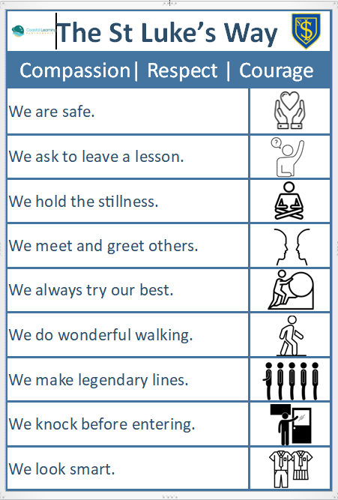
Appendix 1


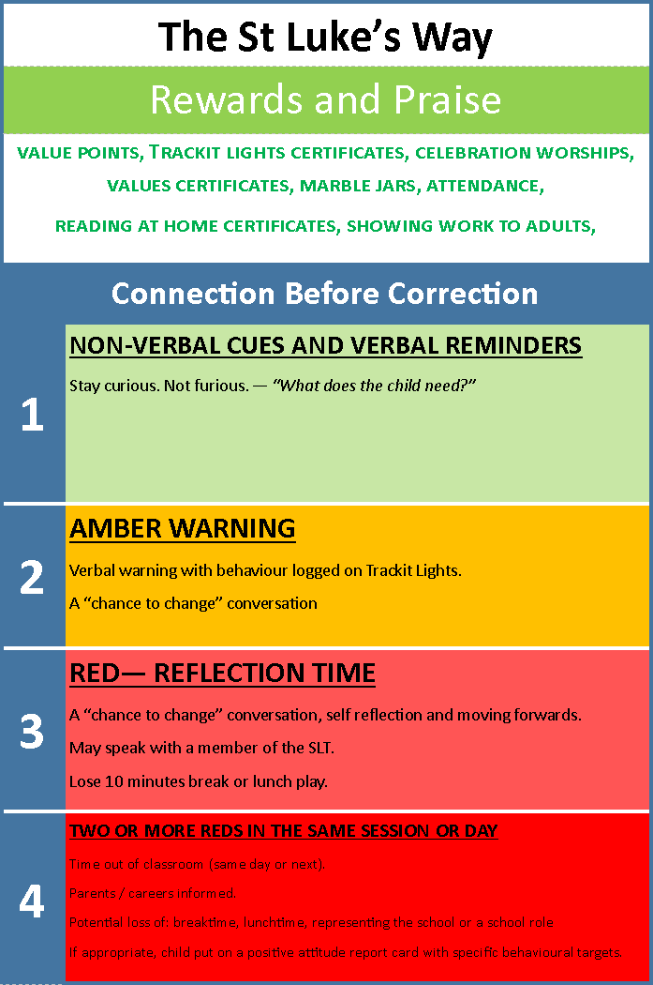

Appendix 3
Re-integration Meeting Form
Child’s Name:………… Date of Meeting:…… ….……………………..

Before we start: | Outline of concerns moving forward: | School response: | Important Documents: | Discussion and Comments from Parents:
Reason for exclusion discussed | Concerns relating to education and safety of self and others | What the school will do | e.g. CP plan, EHCP, IEP, behaviour plan, care plan etc | Parental response, comments and concerns
Present:………………………………………. Exclusion type / length: ………………………….

