Reading Long Term Plan
Overview:
The English curriculum seeks to equip pupils with a strong command of spoken and written language in readiness for their next phase in education, to be successful life-long learners and participants in society. We acknowledge the importance of English within each subject of the primary curriculum, and believe that a depth of learning secured within all aspects of this core subject, enables access to the full breadth of a rich and vibrant curriculum, and broadens pupils’ experiences.

The English curriculum aims to develop effective communication skills so pupils can speak and write fluently to communicate with others, and can read confidently and listen carefully so others can communicate with them.

Reading:
We aim to develop a life-long love of Reading as this offers pupils the chance to develop culturally, emotionally, intellectually, socially and spiritually. Pupils are encouraged to read and enjoy a broad range of challenging fiction and non-fiction texts to support their development of a love of literature and understanding of language.

Reading can be separated into the two dimensions of word reading and comprehension. The structure of the English curriculum acknowledges that different kinds of teaching is required for each aspect though the provision of two sequences - Phonics and Reading.

The Reading sequence teaches the skills that develop and support good comprehension. These draw on linguistic knowledge (in particular of grammar and vocabulary) and on knowledge of the world. The Reading curriculum develops confident, fluent readers in recognition that these skills are essential to enable pupils to read to acquire knowledge and to build upon what they already know.

The knowledge and skills that pupils need in order to comprehend are very similar at different ages. This is why the programmes of study for comprehension in years 3 and 4 and years 5 and 6 are similar: the complexity of the writing increases the level of challenge.

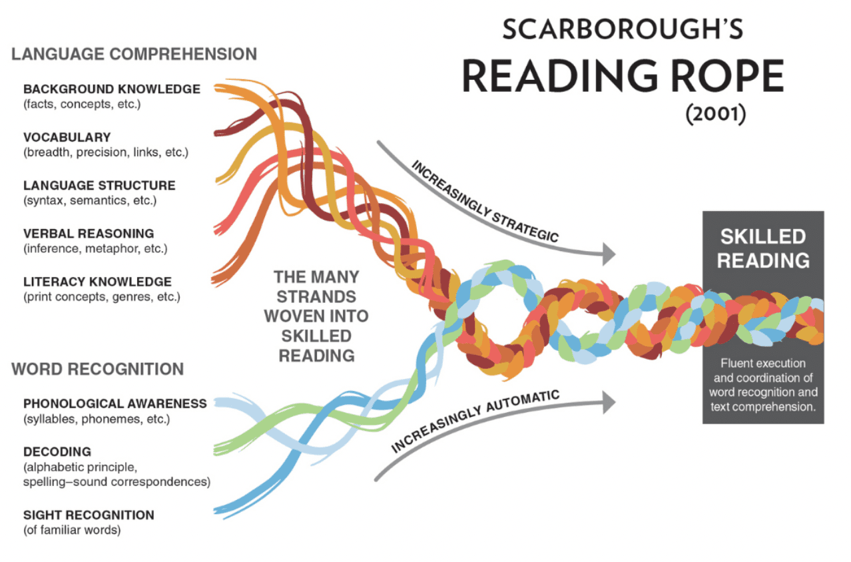

LKS2
UKS2

WORD READING
EYFS & KS1

COMPREHENSION

In each year, pupils will be learning to:

 |  |  | Pre-school | Reception | Year 1 | Year 2 | Year 3 | Year 4 | Year 5 | Year 6
Word Reading: Fluency  Word reading is also covered in detail on the school’s phonics map, so specific phonics are not included here |  |  | understand the five key concepts about print:  -print has meaning  -print can have different purposes  -we read English text from left to right and top to bottom  -the names of the different parts of a book (see terminology)  -page sequencing  recognise their own name in print | recognise own name, advertising logos and signs in the environment. | read words containing –s, –es, –ing, –ed, –er and –est endings, and know this changes the meaning of the word (beginning of morphology)  read words with contractions [for example, I’m, I’ll, we’ll], and understand that the apostrophe represents the omitted letter(s)  recognise known words within new words and link their meaning to those already known  break up unknown polysyllabic words into syllables/chunks and break down each part individually  use known patterns (analogy) to read unknown words (eg to read the word ‘coat’, use their known word ‘boat’) | read most words quickly and accurately, without overt sounding and blending  sound out unfamiliar words accurately, automatically and without undue hesitation  know the root word carries most of the word meaning  read words containing common suffixes (-ly, -ful -ment, -ness), and know this changes the meaning of the word (beginning of morphology) | Make reference to school specific English tracker/year group word list  refer to Appendix 1  read words containing the common prefixes (un-, dis-, mis-,in-, il-, re-, sub-, inter-, super-, anti-, auto- ), and know how this changes the meaning of the word  read words containing the common suffixes (-ous, ), where -ly is used to change adjectives to adverbs  read Year 3 words that are spelling exceptions, noting the unusual correspondences between spelling and sound, and where these occur in the word  read new words, testing out different pronunciations | Make reference to school specific English tracker/year group word list  refer to Appendix 1  read plural words with a possessive apostrophe  read words containing the common suffixes (-ous, ), where -ation is used to change verbs to nouns  -ion, -ian where pronunciation sound like –tion  read Year 4 words that are spelling exceptions, noting the unusual correspondences between spelling and sound, and where these occur in the word | Make reference to school specific English tracker/year group word list  refer to Appendix 1  read words containing the common suffixes -able - ible  read Year 5 words that are spelling exceptions, noting the unusual correspondences between spelling and sound, and where these occur in the word | Make reference to school specific English tracker/year group word list  refer to Appendix 1  read words containing hyphen between prefix and root  read words containing the common suffixes -ant, ance, -ancy, -ent, -ence, ency, -ably, -ibly, -fer  read Year 6 words that are spelling exceptions, noting the unusual correspondences between spelling and sound, and where these occur in the word
Word Reading: Understanding |  |  |  | know words for human emotions: angry, happy, sad, scared, nervous, frustrated, excited | recognise known words within new words | pause when reading to check understanding
Comprehension | Comprehension strategies |  | ask questions about what they see in books and they have had read to them (once questions have been modelled)  join in with and finish known sentences, especially repeated phrases and rhyme in stories | identify words they do not understand and ask for clarification  identify parts of stories they do not understand and ask for clarification  understand the title tells us something about the book | recognise that authors use paragraphs, headings and subheadings to make the content clearer | check sentences make sense to them as they read and correct inaccurate reading caused by omission, substitution, mispronunciation, insertion, repetition, reversal | check that the text makes sense to them, explaining their understanding and the meaning of words in context  ask questions to improve their understanding of a text | identify how language, structure, and presentation contribute to meaning | check that a book makes sense to them, explaining their understanding and identifying where an author is deliberately obscuring meaning  ask questions to improve their understanding about specific aspects of a text  compare structure and presentation and explain how they contribute to meaning | evaluate how authors use language, including figurative language, considering the impact on the reader
Comprehension | Retrieval  including sequencing and summarising |  | retrieve information from pictures of familiar objects  discuss characters in books being read  find the title of the book | pick out familiar words and labels in the classroom  identify the main events, setting and principle characters in a book they have been read  pick out simple information from books (fiction and non-fiction)  scan for a single letter on a display | find simple comparisons and differences (e.g. between characters and settings)  find characteristics of fairy tales and traditional tales: repeated language e.g. Once upon a time…, simple story structure, good and bad characters  understand that retrieval is finding information directly from the text  scan a text for specific word or phrase | pick out the sequence of events in books (fiction and non-fiction)  identify items of information which are related within a text (e.g. how a character develops through a story or the three most important facts in a short passage of non-fiction)  find recurring language across different stories and poems, e.g. foe instead of enemy  pick out favourite words and phrases  retrieve and explain details about characters, events and information  use contents page, simple index and subheadings to find information  scan a text for specific information in response to written question  understand the difference between close reading and scanning | find words that capture the reader’s interest and imagination  identify the main ideas from one paragraph and summarise it  use graphs, charts or diagrams to find factual information  skim a text quickly to get a general idea of meaning  with support, justify their views about what they have read | find phrases that capture the reader’s interest and imagination  identify the main ideas drawn from several paragraphs on the same topic and summarising these  quote key evidence from a text and identify less important information  understand the difference between skim, scan and close reading  increasingly independently, justify their views about what they have read (by the end of year 4)  retrieve and record information from non-fiction  know what information they need to look for before they begin reading (non-fiction) | summarise the main ideas drawn from across chapters, identifying key details that support the main ideas/ events  understand why some evidence is more useful and more reliable than other evidence  justify why they have included specific information in a summary  understand the difference between paraphrasing and quotation  use a complex index  skim and/ scan in order to identify text to close read  compare characters, consider different accounts of the same event and give viewpoints (both of authors and of fictional characters), within a text | summarise the main ideas drawn from across chapters, identifying quotations that support the main ideas  use quotes, paraphrasing and adapting text to give evidence  make judgements about evidence e.g. reality and fantasy, adequacy and validity, appropriateness and worth  independently choose appropriate the combination of skills: skim, scan, close read in response to written questions
Comprehension | Inference  Coherence  Inference across a sentence or whole text.  Completed at the point of reading.  Elaborative  Gap-filling or knowledge based.  Completed either at the point of reading or after.  Global  Completed after reading.  When coherence and elaborative inference has aided full comprehension of the text. |  | EI  relate known sequences (eg getting dressed, their day) to the text | EI  infer character feelings using pictures  infer character’s feelings through linking them to own  infer character’s feelings using information explicitly stated in the text | CI  identify grammatical feature of a sentence that infer additional information – pronouns, sequencing, plurals, tenses  understand that inference is a suggestion based on other information that they know or they have retrieved from the text  understand that some inferences are drawn as you read  make inferences on the basis of what is being said  make inferences on the basis of what is being done | EI  draw on what they already know and new vocabulary provided by the teacher  identify vocabulary which infers additional information e.g. navy = dark blue  CI  identify grammatical features of a sentence that infer additional information - punctuation (eg !), tenses, prefixes and suffixes, coordinating and subordinating conjunctions  make inferences on the basis of what is being said and done | EI  make knowledge based inferences linked to topic specific vocab  infer the meaning of a word from its context eg within a sentence, subheading  CI  identify grammatical features of a sentence that infer additional information – differences between tenses, prefixes and word families, conjunctions, adverbs and prepositions, inverted commas  GI  identify a theme in individual paragraphs and chapters  understand that some inferences are drawn after reading the whole text  infer characters’ feelings and thoughts from their actions  justify inferences with at least two sources of evidence | EI  explain the meaning of a word linked to examples linked to context  CI  identify grammatical features of a sentence that infer additional information – standard and non-standard English, fronted adverbials, modifying adjectives  GI  identify a theme in whole text  infer characters’ feelings, thoughts and motives from their actions  justify inferences with multiple sources of evidence | EI  adjust initial thinking about the meaning of a word through gathering more information from the context  infer meaning from figurative language (eg personification, similes, metaphors, abstract language, onomatopoeia)  CI  identify grammatical features of a sentence that infer additional information: prefixes/ suffixes, relative clauses, adverbs, modal verbs, adverbials, commas to mark clauses, commas for parenthesis, brackets, dashes  GI  identify themes within a text  distinguish between statements of fact and opinion | EI  draw on prior learning and new vocabulary to make inferences linked to a new text  CI  identify that language choice and register can infer formality and intended audience  identify grammatical features of a sentence that infer additional information active, passive, subjunctive, adverbials, ellipsis, semi-colon, colon, hyphens  GI  identify similarities/shared themes between texts  distinguish between statements of bias, fact and opinion across a range of texts  compare characters, consider different accounts of the same event and give viewpoints (both of authors and of fictional characters), across more than one text
Comprehension | Inference | Prediction |  | understand a prediction must be based on a reason  accurately predict key events | make a prediction based on stated facts | explain a prediction clearly referencing the text  update a prediction whilst reading | explain why they have modified a prediction | base a prediction on an established theme in a text | predict what might happen from details stated and implied | make predictions about characters, plots and themes of stories based on knowledge of fiction genres and books by the same author

Terminology  (use when discussing texts with children)  HYPERLINK TO READING TERMINOLOGY DOC | Cover  Book  Page  Page number  Front  Back  Title  Author  Left  Right  Print  Picture  Story  Question  Comic  Magazine  Newspaper  Characters  Start  End | Fiction  Non- fiction  Setting  Action  Event  Plot  Next  First  Beginning  Find  Title | Retrieve  Retrieval  Pick out  Infer  Inference  Suggest  Suggestion  Predict  Prediction  Characters  order  Fairy tale  Traditional tale  Poem  Rhyme  Rhythm  Scan  Re-read  comparison  similarity  difference | Locate  Sequence  Structure  Poetry  Modern  traditional  Opinion  View  Skim | Summarise  Condense  Morphology  Etymology  Explicit  Implicit  Motive  Effect  Evidence  Strategy  Purpose  Genre  Audience  Context  Choice  Theme  fact  opinion  Language | Justify  Identify  Clarify  Myth  Legend  Play script  Intonation  Tone  Volume  Reference | literary heritage  traditional  cultures  simile  metaphor  personification  onomatopoeia  figurative language  abstract  Deduce  Concise | Formality  Register  Evaluate  Conclude  Speculate  Adequacy  Validity  Impression

Reading Entitlement:
 | Pre-school | Reception | Year 1 | Year 2 | Year 3 | Year 4 | Year 5 | Year 6
Book Coverage | Please see school specific book map
Reading Entitlement | As well as books, provide opportunities to experience different forms of print, e.g. comics, magazines, hard and soft books, pop-up books, big books, poems, stories (of children) from different cultures.  Engage in a variety of reading activities: individual, paired, small group, whole class.  Encourage children to use stories they hear in their play, using pictures, toys, small world objects within role-play, real objects and puppets. | Encourage children to use stories they hear in their play, using pictures, toys, small world objects within role-play, real objects and puppets.  Re-read books to build confidence in word reading, their fluency and their understanding and enjoyment. | Key stories, non-fiction, poems, rhymes, fairy tales, traditional tales, key stories (eg Easter and Christmas)  …at a level beyond that at which they can read independently. | Stories, narratives, non-fiction (structured in different ways),  contemporary and classic poetry,  fairy tales, traditional tales,  …at a level beyond that at which they can read independently | Continue reading to and with children:  fiction, poetry, plays, non-fiction texts, reference (eg dictionary, thesauruses, atlases), topic text books  Reading books that are structured in different ways and reading for a range of purposes (enjoyment, information, communication) | Continue reading to and with children:  fiction, myths, legends, fairy tales, poetry (different types e.g. free verse and narrative), plays, non-fiction texts, reference (eg dictionary, thesauruses, atlases), topic text books  Reading books that are structured in different ways and reading for a range of purposes (enjoyment, information, communication) | Continue reading to and with children:  fiction, myths, legends and traditional stories, modern fiction, fiction from our literary heritage, and books from other cultures and traditions  Poetry, plays, reference books, text books.  Reading books that are structured in different ways and reading for a range of purposes (enjoyment, information, communication). | Continue reading to and with children:  fiction, myths, legends and traditional stories, modern fiction, fiction from our literary heritage, and books from other cultures and traditions  Poetry, plays, reference books, text books.  Reading books that are structured in different ways and reading for a range of purposes (enjoyment, information, communication).

Pre-School
 | Pupils will be taught…  (Key learning in bold) | Examples of this in use
Word reading: fluency | Understand the five key concepts about print:  - print has meaning  - print can have different purposes  - we read English text left to right and top to bottom  - Understand that symbols on a page have meaning and can be read  - the names of different parts of a book  - page sequencing  - Know where text starts.  - Understand the difference between text and illustration.  - Recognise the front and back cover.  - Know which way to turn pages.  Recognise their own name in print.  - recognise some known letters.
Comprehension Strategies | Ask questions about what they see and hear in books read to them (once questions have been modelled).  - Ask questions about words that they see around their environment and that they hear read to them - To ask questions about a picture in a picture book.  - Ask questions about content they have had read to them.  Join in and finish known sentences, especially repeated phrases and rhymes in stories.
Retrieval | Retrieve information from pictures of familiar objects.  Discuss the characters in books being read.  - Identify who the main character is in a story that has been read to them.  - Act in character, from a book read to them, in role play.  - Use stories, which they have heard, when playing.  Find the title of the book. | Draw a picture about what has been read to them.  Begin to develop complex stories using small world equipment like animal sets, dolls and dolls houses, etc.
Inference | Relate known sequences (e.g. getting dressed, their day) to the text. | Understand ‘why’ questions, like: “Why do you think the caterpillar got so fat?”
Prediction | Predict what might happen next, based on their own known sequences, while following a picture story.
Terminology | Cover, Book, Page, Page number, Front, Back, Title, Author, Left, Right, Print, Picture, Story, Question, Comic, Magazine, Newspaper, Characters, Start, End

EYFS - Reception
 | Teaching Points  (Key Learning Points in bold) | Examples of this in use
Word reading and fluency | Recognise own name, advertising logos and signs in the environment  - Recognise own name  - Recognise signs in the environment  - Recognise advertising logos  (Word reading is also covered in detailed phonics map, so specific phonics is not detailed here)  Know that a full stop tells the reader that it is the end of a sentence
Word reading: understanding | Know words for human emotions: angry, happy, sad, scared, nervous, frustrated, excited
Comprehension Strategies | Identify words they do not understand and ask for clarification  - Ask questions about new words  Identify parts of stories they do not understand and ask for clarification  - Ask questions about the part of the story they do not understand  Understand the title tells us something about the book
Retrieval | Pick out familiar words and labels in the classroom  Identify the main events, setting and principle characters in a book they have been read  - Know that an event is a key thing that happens  - Know that a setting is where something takes place.  - Know that a character is a person, animal or creature that is in a story  - Know that a main character is the person, animal or creature at the centre of the story  Pick out simple information from books (fiction and non-fiction)  - Answer a simple retrieval question  Scan for (find) a single letter on a display  - Recognise their own name in print | Find the name of the plant.
Inference | Infer characters’ feelings using pictures  - Identify an emotion a character might be feeling  - Recognise how someone is feeling from the way they behave (in real life), e.g. know some of the clues for spotting is someone is angry (clenched fists, shouting, red face) or upset (crying, quiet).  Infer characters’ feelings through linking them to own experiences  - Give verbal explanations to explain why  Infer characters’ feelings using information explicitly stated in the text  - Identify a word or phrase that suggests how a character might be feeling  - Explain why a word or phrase was selected
Prediction | Understand a prediction must be based on a reason  Accurately predict key events  - Predict events within familiar contexts  - Describe what might happen next while listening to a story | What do you think might happen next? E.g. a ball being kicked towards a window, or the boat is rocking, character losing balance.  For example, in ‘Oh no George’: George sees a cake. What will George do? (eat the cake)
Terminology | Fiction, Non- fiction, Setting, Action, Event, Plot, Next, First, Beginning, Find, Title

YEAR 1
 | Teaching Points  (Key Learning Points in bold) | Examples of this in use
Word reading: Fluency | Read words containing –s, –es, –ing, –ed, –er and –est endings, and know this changes the meaning of the word (beginning of morphology)  - Read plurals containing -s  - Read plurals containing -es  - Read verbs containing -ing  - Read verbs containing -ed  - Read words containing -er  - Read words containing -est  Read words with contractions [for example, I’m, I’ll, we’ll], and understand that the apostrophe represents the omitted letter(s).  Recognise known words within new words and link their meaning to those already known  Break up unknown polysyllabic words into syllables/chunks and break down each part individually  Use known patterns (analogy) to read unknown words (e.g. to read the word ‘coat’, use their known word ‘boat’)  Know that a pause in reading aloud is needed at a full stop  Understand that a question mark is used to show when someone is asking a question  Know that re-reading improves fluency  - Correct an inaccurate word when prompted
Word reading: Understanding | Recognise known words within new words  Explain what words mean by linking to known words, when supported by an adult
Comprehension strategies | Recognise that authors use paragraphs, headings and subheadings to make the content clearer  Know the difference between a fiction and a non-fiction book  - Know that some books tell us information and some books tell us stories.  - Know that fiction describes imaginary events and people.  - Know that non-fiction is informative or factual.  - Know some of the features of non-fiction texts, e.g. title, text in boxes, pictures, diagrams, and that these support understanding  - Know that a heading tells us about the information on that page  - Know that captions tell us information about the pictures  Know that re-reading improves understanding  Say what they know about events or topics prior to reading | Identify features within texts
Retrieval | Find simple comparisons and differences (e.g. between characters and settings)  - Make simple comparisons between two characters  - Retrieve details about characters’ appearance, behaviour and the events that happen to them, using details from the text.  Find characteristics of fairy tales and traditional tales:  - repeated language e.g. Once upon a time…  - simple story structure  - good and bad characters  - Know that ‘Once upon a time…’ is a feature of how fairy stories open, and ‘They all lived happily ever after.’ is an ending.  - Know that princes, princess, fairies, are generally good characters; and witches, trolls, wolves, are generally bad characters.  Understand that retrieval is finding information directly from the text  Scan a text for specific word or phrase  Describe what has happened in a story so far in order | For example, explain what the differences are between Little Red Riding Hood and the wolf.  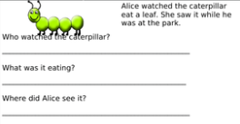  Find and copy…  What is this story about?  When reading together, say what has happened in the story so far.
Inference | Identify grammatical feature of a sentence that infer additional information – pronouns, sequencing, plurals, tenses  - Understand that punctuation tells the reader something  Understand that inference is a suggestion based on other information that they know, or they have retrieved from the text  - Make inferences from pictures with a small amount of text.  - Understand that words and pictures suggest what might be happening, and doesn’t tell us directly  Understand that some inferences are drawn as you read  Make inferences based on what is being said  - Discuss what is suggested about a character from what they say  - Identify how a character in a story might be feeling  Make inferences based on what is being done  - Discuss what a character’s actions or behaviour suggest about them  - Explain why a character might have behaved a certain way, based on clues in the text | Pupils explain that the pronoun ‘she’ links to a female character, that plurals indicate more than one and that past tense verbs mean the story has already happened  How do you think the character is feeling?  Why was ____ feeling worried?  For example, ‘tears rolled down her face’ (she is crying and upset)  Explain how you know this, e.g. she’s sad because she has tears  Why did ____ happen?  For example, ‘Why did the window break?’ (because the football hit it)  e.g. character types (e.g. good, bad, evil, hero) based on actions
Prediction | Make a prediction based on stated facts  - Know that predictions should be linked to what has already happened in the story  - Make a prediction that makes sense in the context of the story  - Anticipate key events in stories being read to them | What do you think will happen next?  What do you think the character will do next?  For example, in the book ‘Mogg’. Mogg is outside and hungry. A burglar breaks in to the house. As Mogg is hungry it is likely he is going to go back into the house.  ‘What do you think will happen next? (I think the burglar will get caught)
Terminology | Retrieve, Retrieval, Pick out, Infer, Inference, Suggest, Suggestion, Predict, Prediction, Characters, order, Fairy tale, Traditional tale, Poem, Rhyme, Rhythm, Scan, Re-read, comparison, similarity, difference

YEAR 2
 | Teaching Points  (Key Learning Points in bold) | Examples of this in use
Word reading: fluency | Read most words quickly and accurately, without overt sounding and blending  Sound out unfamiliar words accurately, automatically and without undue hesitation  Know the root word carries most of the word meaning  Know that suffixes are groups of letters added to the end of a root word  Read words containing common suffixes (-ly, -ful -ment, -ness), and know this changes the meaning of the word (beginning of morphology)  - Read words containing -ly  - Read words containing -ful  - Read words containing -ment  - Read words containing -ness  - Know that suffixes change the meaning of a word  Check words make sense to them as they read and self-correct inaccurate reading.  Recognise the purpose of punctuation: . ? ! “” using punctuation to support intonation in reading.
Word reading: Understanding | Pause when reading to check understanding  Identify a word they do not understand and suggest what it might mean by linking it to another word they know  Identify the word class/job of the new vocabulary in the sentence and how this contributes to meaning  Know that glossaries are alphabetical lists of words in a particular text with the definitions for those words.  - Agree which definition is the most useful, given the context. | Discuss and clarify the meaning of new words, linking new meanings to known vocabulary.
Comprehension Strategies | Check sentences make sense to them as they read and correct inaccurate reading caused by omission, substitution, mispronunciation, insertion, repetition, reversal
Retrieval | Pick out the sequence of events in books (fiction and non-fiction).  - Order key events in a story  - Explain the use of different organisational features in non-fiction texts, including alphabetical order, contents, layout, illustrations, and captions  - Know that a contents page is a list, usually found before the start of any writing that outlines what is included  - Discuss the difference between language used in labels and in captions  Identify items of information which are related within a text (eg how a character develops through a story or the three most important facts in a short passage of non-fiction).  - Pick out key changes, e.g. a character’s mood  Find recurring language across different stories and poems, e.g. foe instead of enemy  Pick out favourite words and phrases  - Discuss why an author might have chosen a particular word and the effect they were wanting to achieve. | State the correct answer when several similar multiple choice answers are given.  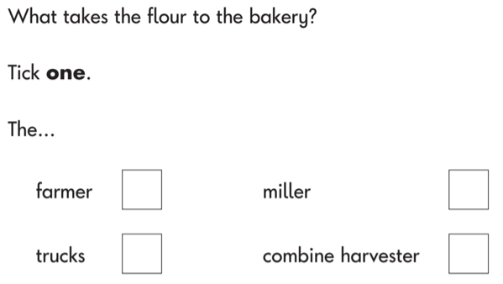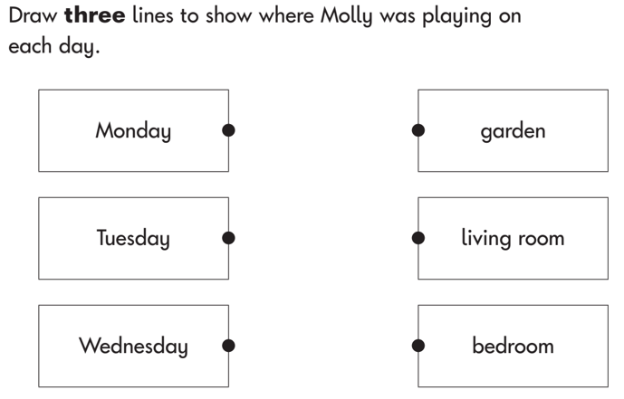  Retrieve words, e.g ‘Find and copy one word that makes the apples sound tasty.’  Contents: Which page would I go to to find out about…?  Glossary: Why is the word X in bold? What does it mean?
Retrieval | Retrieve and explain details about characters, events and information  - Know that stories can be set in different times periods  - Draw together information from across a number of sentences to sum up what is known about a character, event or idea  - Make links between the book they are reading and other books they have read  Use contents page, simple index and subheadings to find information  - Know that non-fiction texts are structured in different ways  - Retrieve information from non-fiction texts  - Understand that writers can use paragraphs, numbering, headings and subheadings to make writing clearer  Scan a text for specific information in response to written question  Express and record their understanding of information orally, using simple graphics or in writing, e.g. matching, linking information, ordering, tabulating and copying.  Understand the difference between close reading and scanning  Identify differences between poetry and narrative  - Know that some poems are not written in sentences | Identify items of information which are related, within a text:  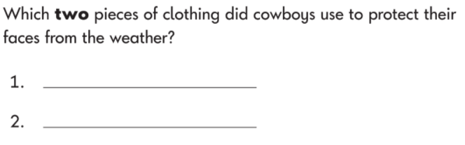  Discuss the sequence of events in books and how items of information are related, e.g. Number the sentences below from numbers 1-4 to show the order that they happen in the story / the order that they character said them  Explain what has happened so far in what they have read (summarise).  Pick out key changes (e.g. in a character’s mood) or from across story, e.g. At the start of the book the character is feeling angry, they calm down in the middle and are happy by the end.  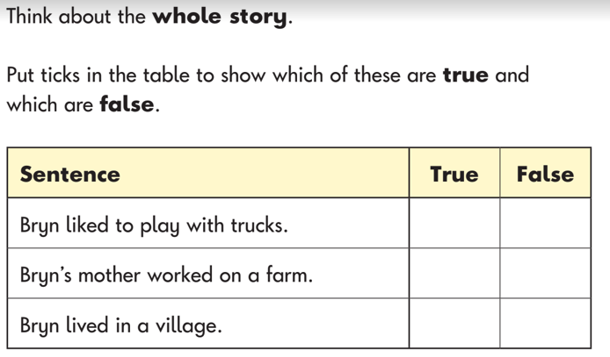
Inference | Draw on what they already know, and new vocabulary provided by the teacher  Identify vocabulary which infers additional information e.g. navy = dark blue  Identify grammatical features of a sentence that infer additional information - punctuation (eg !), tenses, prefixes and suffixes, coordinating and subordinating conjunctions  - Understand that verbs can be used to recognise the tense of a text  Make inferences based on what is being said and done  - Use ‘because’ to justify inferences  - Explain what happened and why something occurred  - Explain the effect that a character’s actions have on other characters  - Make simple inferences about how a character is feeling based on their speech | Make inferences about what has been said or done.  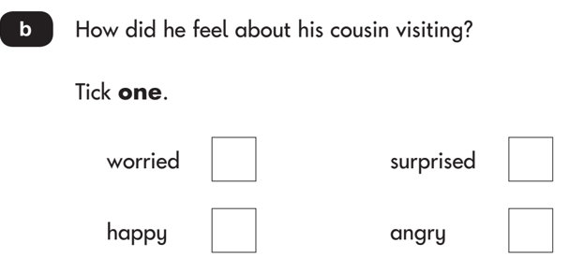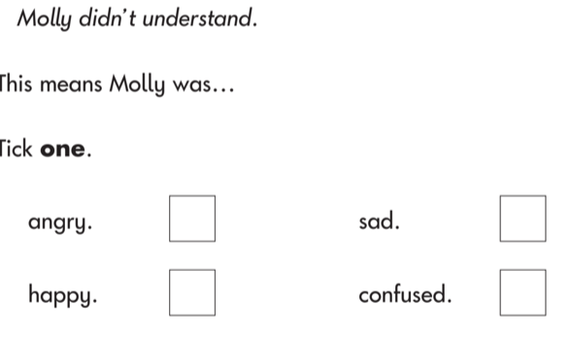  Why did … say because she was feeling..?  Why was … feeling worried?  Why did .. happen?  How do you know that? …. was excited (link to what a character says) because it says…  Why do animals have to be careful when drinking from the waterhole? (because predators might walk behind them and pounce)  In conversation with the teacher and their peers, talk about the grammatical features of a sentence that infer additional information, e.g. ‘I know this is past tense because it has –ed endings on verbs.
Prediction | Explain a prediction clearly referencing the text  Update a prediction whilst reading | Explain why they have made a prediction, for example using the word ‘because’.  Reflect on whether, from what they have read, a prediction is sensible or not.  Which of these do you think the child is likely to say at the end of the school trip? Why?  Which of these things do you think is most likely to happen next and why?
Terminology | Locate, Sequence, Structure, Poetry, Modern, traditional, Opinion, View, Skim

YEAR 3
 | Teaching Points  (Key Learning Points in bold) | Examples of this in use
Word reading: fluency | Make reference to school specific English tracker/year group word list.  Refer to Appendix 1  Read words containing the common prefixes (un-, dis-, mis-,in-, il-, re-, sub-, inter-, super-, anti-, auto- ), and know how these change the meaning of the word  - Know that a prefix is defined as a pair or group of letters added to the front of a root word  - Identify the prefix and root word  - Understand the meaning of common prefixes  Read words containing the common suffixes (-ous,) and words where -ly is used to change adjectives to adverbs  - Read words containing the common suffix (-ous)  - Read words containing the suffix –ly when it has changed an adjective to adverbs  Read Year 3 words that are spelling exceptions, noting the unusual correspondences between spelling and sound, and where these occur in the word  - Read the word as it should be pronounced  - Identify where in the word the unusual grapheme phoneme correspondence is positioned  - Identify the unusual grapheme phoneme correspondence  Read new words, testing out different pronunciations
Word reading: Understanding | Explain the meaning of unfamiliar words by using the context
Comprehension Strategies | Ask questions to improve understanding of a text  Check that the text makes sense to them, discussing their understanding and explaining the meaning of words in context  - Recognise key vocabulary and language features from different genres
Retrieval | Find words that capture the reader’s interest and imagination  - Find an individual word and explain why it is interesting  - Find a phrase and explain why it is interesting  - Understand that we use our imagination when reading to create a visual image in our minds  - Find an individual word and explain how it creates or adds to our imagination  - Find individual words and phrases within a section of writing that support imagination  - Identify patterns in language, e.g. repetition, rhyme, alliteration  Identify the main ideas from one paragraph and summarise it  - Determine the main point of a paragraph  - Identify which points support the main idea of the paragraph  - Know that summarising is a reduction in length of a text  - Know that summarising involves removal of language that adds detail e.g. adjectives and adverbs  - Know that summarising links ideas together  - Know that summarising may involve alteration of sentence structure and punctuation e.g. listing ideas from several sentences in one sentence, using commas for a list  - Know that summarising only includes the key points – and not all the supporting detail – in a text  Use graphs, charts or diagrams to find factual information  - Understand that graphs, charts and diagrams can support text by adding further information  - Understand that graphs, charts and diagrams can provide clearer visual information for the reader  - Understand that graphs, charts and diagrams enable the reader to retrieve information quickly  - Retrieve factual information from a graph  - Retrieve factual information from a chart  - Retrieve factual information from a diagram  Skim a text quickly to get a general idea of meaning  - Understand that when you skim read you do not read the whole text  - Know when skim reading, which parts of the text are more likely to give you an idea of the content e.g. title, subheadings, introduction, conclusion, initial sentences in a paragraph  With support, justify their views about what they have read | e.g. produce an annotated story map to represent a text that has been read  Note: skimming is a separate skill from scanning
Inference | Make knowledge-based inferences linked to topic-specific vocabulary  Infer the meaning of a word from its context e.g. within a sentence, subheading  - Know that the position of a word in a sentence will indicate its purpose within that sentence and its subsequent word class  - Know that additional detail in the text can help you infer the meaning of a word  Identify grammatical features of a sentence that infer additional information – differences between tenses, prefixes and word families, conjunctions, adverbs and prepositions, inverted commas  - Identify an author’s viewpoint where it can be retrieved through using synonyms  Identify a theme in individual paragraphs and chapters  - Know that a theme is identified when you have finished reading  - Know the difference between implicit and explicit  - Know that a theme is usually inferred (implicit)  - Know that a theme of a paragraph is typically its main idea  - Understand a theme is a recurring idea across a text e.g. love, morals, conflict  - Understand the theme can be inferred from events, characters’ actions and content  Understand that some inferences are drawn after reading the whole text  - Know that an author develops content e.g. characterisation over a piece of text and this is supported by selected vocabulary and an character’s actions within the story  Infer characters’ feelings and thoughts from their actions  Justify inferences with at least two sources of evidence  - Identify the part of the text that supports an inference | Note: ensure curriculum coverage of linked subject has been taught  e.g. The azure bird flew away (‘azure’ is part of the subject and is in front of the noun, making it an adjective. It is describing the bird.  e.g. when inferring the meaning of an unknown word, the subheading will link to subsequent information  Ensure grammar content has been taught in Writing
Prediction | Explain why they have modified a prediction  - Know that a prediction is an inference about what will happen based upon what has been read so far  - Make a prediction based upon what has been read so far  - Identify the piece of text which supports a change to their prediction | Note and revisit prediction frequently to review which are still plausible and which are no longer appropriate
Terminology | summarise, condense, morphology, etymology, explicit, implicit, motive, effect, evidence, strategy, purpose, genre, audience, context, choice, theme, fact, opinion, language

YEAR 4
 | Teaching Points  (Key Learning Points in bold) | Examples of this in use
Word reading: fluency | Make reference to school specific English tracker/year group word list.  Refer to Appendix 1  Read plural words with a possessive apostrophe  - Know that the possessive apostrophe shows that an object belongs to a subject  - Know that plural means more than one  Read words containing the common suffixes (-ous, ), where -ation is used to change verbs to nouns, -ion, -ian where pronunciation sound like –tion  - Read words containing the suffix –ous  - Read words where –ation is used to change verbs to nouns  - Read words containing –ion and –ian where pronunciation sound like –tion  Read Year 4 words that are spelling exceptions, noting the unusual correspondences between spelling and sound, and where these occur in the word  - Read the word as it should be pronounced  - Identify where in the word the unusual grapheme phoneme correspondence is positioned  - Identify the unusual grapheme phoneme correspondence
Word reading: Understanding | Explain the meaning of key vocabulary, within the context of the text
Comprehension Strategies | Select known strategies to aid comprehension  Identify how language, structure, and presentation contribute to meaning | e.g. asking questions, finding answers, refining thinking, modifying questions, constructing images  e.g. narrative order, new characters being introduced, non-fiction organisational features and how these support the reader in finding information, layout of poetry
Retrieval | Find phrases that capture the reader’s interest and imagination  - Find a phrase and explain why it is interesting  - Find multiple phrases within a section of writing that support imagination  Identify the main ideas drawn from several paragraphs on the same topic and summarise these  - Identify the key paragraphs in a text  - Summarise in different ways, including key information  Quote key evidence from a text and identify less important information  - Identify the key information in a text  - Explain the importance of key information in the text  - Use all organisational devices within a text to retrieve key information  - Sequence sections of text read  - Increasingly independently, justify their views about what they have read (by the end of year 4)  Understand the difference between skim, scan and close reading  - Know that you skim a text to identify a paragraph or section of text an answer may be located in  - Skim a text, including headings and captions, to gain an overview of the text  - Understand that when you scan, you do not read the whole text  - Know when you scan read, you can scan down or across or both  - Know that scanning is to locate particular information  - Know that scanning helps when retrieving information at speed  - Know that close reading is required when you want to develop a full understanding of the content  Retrieve and record information from non-fiction  - Know what information they need to look for before they begin reading (non-fiction)  - Explain how specific information is organised within a non-fiction text | e.g. written summary, key words, images, charts, tables  headings, sub-headings, captions  use ‘fastest finger’ to find headings  e.g. scanning for descriptive words associated with a setting, scanning for synonyms  using initial graphemes/capital letters/descenders etc. when scanning for a word
Inference | Explain the meaning of a word linked to examples linked to context  - Scan for alternative synonyms and phrases  Identify grammatical features of a sentence that infer additional information – standard and non-standard English, fronted adverbials, modifying adjectives  Identify a theme in a whole text  - Understand that novels often have common themes e.g. good vs evil, acceptance, courage, perseverance, co-operation, compassion, honesty, kindness, loyalty  - Using sources of evidence from the text, justify their identification of the theme  Infer characters’ feelings, thoughts and motives from their actions  - Infer a character’s thoughts  - Identify the specific character’s actions which support the inference  - Know that a motive is the reason for doing something  - Infer a character’s motive  - Identify the specific character’s actions which support the inference  - Infer the possible causes of events and actions  Justify inferences with multiple sources of evidence | Ensure linked grammar has been taught previously.  e.g. “A theme in this text is kindness because...”
Prediction | Base a prediction on an established theme in a text  - Know that the identification of the theme of a text can support making a valid prediction for what will come next  - Make plausible predictions based on events and actions of characters across a story  - Know that predictions can be made by drawing upon knowledge of other texts and knowledge of the topic
Terminology | justify, identify, clarify, myth, legend, play script, intonation, tone, volume, reference

YEAR 5
 | Teaching Points  (Key Learning Points in bold) | Examples of this in use
Word reading: fluency | Make reference to school specific English tracker/year group word list.  Refer to Appendix 1  Read words containing the common suffixes -able - ible  Read Year 5 words that are spelling exceptions, noting the unusual correspondences between spelling and sound, and where these occur in the word  - Read the word as it should be pronounced  - Identify where in the word the unusual grapheme phoneme correspondence is positioned  - Identify the unusual grapheme phoneme correspondence
Word reading: Understanding
Comprehension Strategies | Ask questions to improve their understanding about specific aspects of a text  Check that a book makes sense to them, explaining their understanding and identifying where an author is deliberately obscuring meaning  - Explore the meaning of words in context  Compare structure and presentation and explain how they contribute to meaning | e.g. compare how poetry structures support the expression of mood, feelings and attitudes
Retrieval | Summarise the main ideas drawn from across chapters, identifying key details that support the main ideas/events  - Know that the main idea in a chapter could be the key event that moves the action forward; a character’s key action; an emerging theme  - Identify the main ideas within a series of chapters  - Evaluate whether further information is needed to support the main idea when summarised  - Identify the links between the main ideas which have been identified to enable effective summary  Understand why some evidence is more useful and more reliable than other evidence  - Understand the purpose of the text and the role of the author in the presentation of information  - Select sources of evidence linked to reason for reading  Justify why they have included specific information in a summary  - Sequence sections of unknown texts based upon knowledge of genre features  - Compare characters, consider different accounts of the same event and give viewpoints (both of authors and of fictional characters), within a text  Understand the difference between paraphrasing and quotation  - Know that a quotation is lifted directly from the text with no alteration  - Know that a paraphrase rewords what someone else has written or said  Use a complex index by skimming and/scanning to identify the text to close read  - Know that an index is found at the back of a book  - Know that an index provides the exact location, by page, of specific information in the book  Recognise examples of metaphors, similes and imagery | Select appropriate texts for information to support ideas in a written piece about fox-hunting.
Inference | Adjust initial thinking about the meaning of a word through gathering more information from the context  - Know that reading on may support the understanding of an unknown word  - Recognise language used by an author for a specific genre and compare to another author, considering impact on the reader  Infer meaning from figurative language (e.g. personification, similes, metaphors, abstract language, onomatopoeia)  - Know that personification is when something non-living is given a human characteristic  - Know that a simile is when an indirect comparison is made using the words ‘like’ or ‘as’  - Know that a metaphor is a direct comparison which states one thing is another  - Know that abstract language refers to intangible ideas rather than real-world objects  - Know that onomatopoeias are words which are written as they sound  Identify grammatical features of a sentence that infer additional information prefixes/suffixes, relative clauses, adverbs, modal verbs, adverbials, commas to mark clauses, commas for parenthesis, brackets, dashes  Identify themes within a text  - Know that a reader can identify overarching themes across the whole text as well as themes within certain parts of the book  - Make links between the causes and effects of actions and events (connected to the theme)  Distinguish between statements of fact and opinion | Personification: The sun’s fingers poked out of the clouds.  Simile: She was as beautiful as a flower.  Metaphor: The test was a killer.  Abstract language: happiness, jealousy, love  Onomatopoeia: bang, clatter, whoosh  Ensure grammar content has been taught previously.
Prediction | Predict what might happen from details stated and implied  - Make predictions based on significant events stated in the text  - Make predictions based on details inferred about events  - Justify predictions in detail with multiple sources of evidence from the text | Categorise predictions as likely/unlikely based on what has been read so far and why some predictions have ceased to be relevant
Terminology | literary heritage, traditional, cultures, simile, metaphor, personification, onomatopoeia, figurative language, abstract, Deduce, Concise

YEAR 6
 | Teaching Points  (Key Learning Points in bold) | Examples of this in use
Word reading: fluency | Make reference to school specific English tracker/year group word list.  Refer to Appendix 1  Read words containing the hyphen between prefix and root  Read words containing the common suffixes -ant, ance, -ancy, -ent, -ence, ency, -ably, -ibly, -fer  Read Year 6 words that are spelling exceptions, noting the unusual correspondences between spelling and sound, and where these occur in the word  - Read the word as it should be pronounced  - Identify where in the word the unusual grapheme phoneme correspondence is positioned  - Identify the unusual grapheme phoneme correspondence
Word reading: Understanding | Explore new vocabulary in context
Comprehension Strategies | Evaluate how authors use language, including figurative language, considering the impact on the reader  - Re-read and read ahead to locate information to support understanding  - Build upon their own ideas  - Select the most appropriate and effective reading strategies | e.g. generating questions to refine thinking, challenging peers with questions, justifying opinions, responding to different viewpoints, noting thoughts in a journal
Retrieval | Summarise the main ideas drawn from across chapters , identifying quotations that support the main ideas  - Identify the most relevant quotation to support the main idea  - Understand that sections of stories are manipulated to create and explore more complex narratives  - Summarise in different ways for different audiences and purposes  Use quotes, paraphrasing and adapting text to give evidence  - Know that a quote can emphasise a point more strongly  - Know that a quote is appropriate when directly ascribing words to an individual, especially when this information is of high importance  - Know that we can adapt text when information is less important  - Know that paraphrasing and adaptation are appropriate when text needs to be shortened  - Determine when to use a direct quote or to make use of paraphrasing or to adapt text  - Make judgements about evidence e.g. reality and fantasy, adequacy and validity, appropriateness and worth  - Find accurate quotations from a whole text  Make judgements about evidence e.g. reality and fantasy, adequacy and validity, appropriateness and worth  - Know that a text’s adequacy can be determined by whether it has the information the reader requires  - Know that a text validity is based on who wrote it, why it was written, and if it is factually sound  - Know that a text’s appropriateness is determined by its readers and its intended use  - Know that a text’s worth may differ according to its reader  Independently choose the appropriate combination of skills: skim, scan, close read in response to written questions  - Use text marking to support answers to questions that require analysis, e.g. mood/setting and to support own viewpoint  Recognise examples of personification, analogy, style and effect | e.g. dual narration, flashback
Inference | Draw on prior learning and new vocabulary to make inferences linked to a new text  - Identify words and phrases that create a particular mood, feeling or attitude  Identify that language choice and register can infer formality and intended audience  - Know that register is the way a person speaks or writes in relation to their audience  - Know that purpose affects language choice and register  - Explain the formality and intended audience for a piece of writing by reference to the language used by the author  Identify grammatical features of a sentence that infer additional information active, passive, subjunctive, adverbials, ellipsis, semi-colon, colon, hyphens  Identify similarities/shared themes between texts  - Compare characters, settings and themes within a text and across more than one text  Distinguish between statements of bias, fact and opinion across a range of texts  - Select from a range of texts/sources of information with a key question or heading in mind  - Justify decisions about a text’s value, quality and usefulness  - Explore texts that are written with strong narrative voice  Compare characters, consider different accounts of the same event and give viewpoints (both of authors and of fictional characters), across more than one text  - Compare and contrast the work of a single author  - Consider different accounts and viewpoints of the same event | Identify words/phrases within non-fiction and poetry, as well as fiction  e.g. persuasive leaflet  Ensure pupils are confident with previous objectives linked to themes  e.g. What types of characters are similar across texts that have a theme of love?  Consider texts written for mixed purposes, e.g. leaflets written for information and persuasion; autobiography is informative but also bias; menus that express implicit opinion  Compare different versions of the same story or different books on the same topic
Prediction | Make predictions about characters, plots and themes of stories based on knowledge of fiction genres and books by the same author  - Use details retrieved and summarised to support predictions  - Compare predictions to the events that occurred and the author’s choices
Terminology | formality, register, evaluate, conclude, speculate, adequacy, validity, impression

