Our Team

Mr Martin Godfrey  Headteacher | Miss Sarah Walton  Assistant Head | Mrs Annabel Pogson  Assistant Head | Mrs Vic Gill  Inclusion Lead / SENCo  Maternity leave | Miss Abigail Waring  SENDCo  Maternity Cover | Ms Kerry Cutler  Family Support Worker
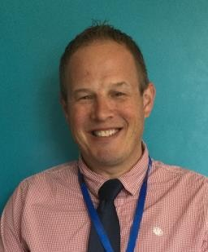 | 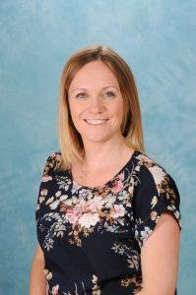 | 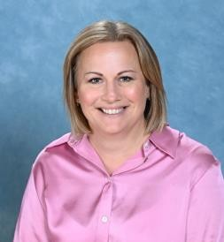 | 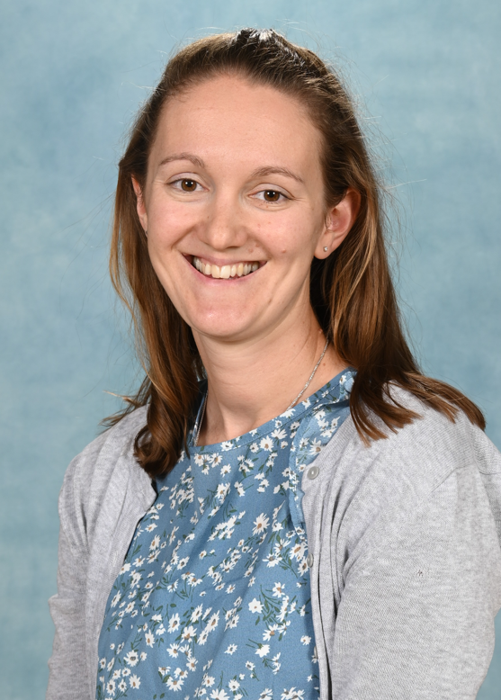 |  | 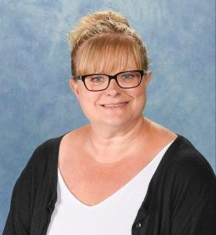
 |  |  | Email: stlukessenco@coastalpartnership.co.uk |  | Email: stlukesfsw@coastalpartnership.co.uk

Contact Details:

 | Infant Site | Junior Site
Address | St Luke’s Primary School  Infant Site  Maxwell Road  Winton  Bournemouth | St Luke’s Primary School  Junior Site  Bemister Road  Winton  Bournemouth
Post Code | BH9 1DL | BH9 1LG
Telephone Number | (01202) 516499 | (01202) 514396
Fax Number | (01202) 539457 | (01202) 521523

 | Respect | Compassion | 
Key People   | Inclusion Lead and SENCo (Special Educational Needs Co-ordinator)  Mrs Vic Gill and Miss Abigail Waring |  | Governor for SEND  Peter Farringdon
About St Luke’s   | St Luke’s Church of England Primary School is in Bournemouth and has two parts for younger and older kids, close to each other. The school cares a lot about love, courage, and hope. It wants every child to feel special and included. They help all kids do their best, especially those who need extra support because of special learning needs. The school works closely with parents and other helpers to make sure everyone gets the help they need. Since 2020, St Luke’s has been part of a bigger group of schools and keeps growing as a kind and welcoming place where kids learn and succeed.
SEND Provision at St Luke’s   | St Luke’s school works hard to help children with special learning needs (called SEND) so they can do their best. Here’s what they do:  - They find out early if a child needs extra help and keep checking how they’re doing.  - They want every child to feel confident, happy, and proud of themselves.  - All kids can learn everything in school, with help that fits what they need.  - Kids with special needs join in all activities and feel part of the school.  - Children get to share their thoughts about the help they get.  - The school talks a lot with parents to work together and support the child.  - They help kids get ready when moving to a new class or school.  - They work with other experts to give the best support.  - The teachers know a lot about helping children with different needs and care about each child.  - They keep checking to make sure the help is working well and change it if needed.  St Luke’s wants every child to feel happy, included, and to reach their full potential!
How do you know if children need extra help?   | At St Luke’s school, teachers watch carefully to see if any child needs extra help. They follow special rules to make sure everyone gets the right support. They look at four main areas where a child might need help: learning, talking and understanding, feelings and making friends, and physical or sensory needs.  How they notice a child might need help:  - If teachers, parents, or carers are worried about how a child is doing.  - If a child isn’t making progress even with good teaching.  - If a child has trouble learning or joining in like other kids.  - If a child finds it hard to talk, get along with others, manage feelings, or handle things like noise or touch.  - If experts like doctors or therapists say a child needs extra help.  - If information from a child’s old school or nursery shows they need support.  Here’s how the school helps step-by-step:  - Teachers first try to help in class by changing how they teach or the classroom setup.  - They keep checking how the child is doing and add more help if needed, like small group work.  - If the child still needs lots of help, the teacher talks with a special teacher called the SENDCo and the parents to make a plan.  - If needed, the child gets a special support plan that’s checked regularly.  - Sometimes, outside experts like speech therapists or counsellors get involved to give more help.  - If the child needs lots of help for a long time, the school can ask for a big plan called an Education, Health and Care Plan to make sure everything needed is provided.  Parents and the child are always involved to make sure the child is happy, learning well, and part of school life.
What should I do if I think my child may have  SEND?   | If you think your child needs extra help at school because of special learning or other needs, it’s important to tell the school early. At St Luke’s, they follow special rules to make sure every child gets the help they need.  Here’s what parents should do:  - Talk to your child’s teacher first. You can talk during meetings or ask for a special chat.  - Share what you notice about your child at home, like if they find learning or making friends hard.  - The school team, including a special teacher called the SENDCo, will help check what kind of support your child might need.  - The school uses a step-by-step way to give more help if your child needs it.  - They look at lots of information about your child to decide if they have special needs.  - Sometimes, experts like speech therapists or doctors might get involved to help.  - The school will keep you updated all the time and work with you to make the best plan for your child.  Remember:  - You know your child best and your ideas matter.  - The school wants to work with you.  - Your child’s thoughts will also be listened to.  - You’re not alone — there are many people ready to help.  - If you’re not sure what to do, contact the SENDCo at the school — they’re there to help you!
How will the school support my child?   | At St Luke’s, they want to help every child learn and feel included, especially those who need extra support.  - Quality Teaching for Everyone  Teachers try their best to make lessons easy to understand for all kids. They use things like pictures, hands-on activities, and simple instructions to help everyone learn.  - Extra Help When Needed  If a child needs more support, they can get:  - Help in class with teachers or assistants.  - Small group or one-on-one lessons to work on things like reading, math, talking, or writing.  - Support from special helpers like speech therapists or counsellors.  - Help to feel calm and confident, sometimes in special groups or with a caring adult during playtimes.  - Teacher’s Job  The class teacher makes sure every child is learning well and works with special support teachers to plan the best help.  - Checking Progress  The school keeps checking how well the support is working and changes it if needed, based on how the child is doing.  - Extra Support and Help  If needed, the school talks with outside experts and the school leaders to make sure everything is going well.  The school always works closely with parents and listens to children’s ideas to make sure everyone gets the best support and feels happy and successful!
How will the curriculum be matched to my child's needs?   | At St Luke’s, the lessons are made to fit what every child needs, so everyone can learn and do well — especially kids who need extra help.  - Teachers plan lessons to help all kids by using things like pictures, easy instructions, and hands-on activities.  - Kids get extra time or help from adults or friends if they need it.  - Teachers check how everyone is doing regularly and meet with the head teacher to make sure no one is falling behind.  - For kids who need extra support, the school makes special plans called Individual Support Plans (ISPs). These plans say what help the child needs and are made with parents and checked often.  - All the teachers and helpers know a lot about how to support children with different needs and keep learning new ways to help.  - The school makes sure lessons are just right for each child, so they can feel confident, learn lots, and be part of everything at school.
How will both you and I know how my child is doing and how will you help me to support my child's learning?   | At St Luke’s, the school and your family work closely together to help children who need extra support.  - The teachers keep a close eye on how your child is doing by looking at their work, doing special tests, and watching how they behave and feel.  - Every few months, there are meetings where parents talk with teachers about how their child is doing and how to help more.  - Parents can also talk to the school anytime if they have questions or worries.  - Teachers share ways to help your child learn at home, so everyone works together.  - Parents’ ideas are important because they know their child best.  - If needed, the school can connect families to extra help like workshops or specialists.  - If you have concerns, start by talking to your child’s teacher. If you need more help, you can talk to the special SENDCo teachers.  If you need more help, please talk to:  - SENDCo / Inclusion Lead: Mrs Vic Gill and Miss Abigail Waring  stlukessenco@coastalpartnership.co.uk  - Family Support Worker: Kerry Culter,  stlukesfsw@coastalpartnership.co.uk  The school believes working together with families is very important to help every child do their best!
What support will there be for my child's overall wellbeing?   | At St Luke’s, helping kids feel happy, safe, and cared for is very important. The school believes when kids feel good inside, they can learn better.  - Teachers look after how kids feel and help with any worries.  - Kids learn about things like being strong, feeling good about themselves, making friends, and taking care of themselves in special lessons called PSHE.  - There are fun activities called ‘Stormbreak’ to help kids stay positive every day.  - If some kids need extra help with feelings or making friends, special helpers like ELSAs support them one-on-one or in small groups.  - There are also cool activities like Lego Therapy and ‘Draw and Talk’ to help kids express their feelings.  - The school has safe places and kind adults for kids to talk to when they need it.  - Everyone is treated with kindness and respect, and kids get to share their ideas through groups like the School Council.  - There are trained adults to help with medical needs like allergies or illnesses.  - Teachers keep learning new ways to support kids’ feelings and health.  The school works with families and others to make sure every child feels safe, happy, and ready to learn and grow!
What specialist services and expertise are available at or accessed by your setting?   | At St Luke’s, we want to help every child who needs extra support to learn and grow. We have lots of skilled teachers and helpers who know about different needs, like autism, hearing or sight problems, and other medical or learning challenges.  - Our teachers learn special ways to help kids with different needs.  - One special teacher called SENDCo, Mrs. Vic Gill, organize the help and make sure everyone gets the right support.  - We also work with outside experts like speech therapists, doctors, and special teachers who come to help when needed.  - These experts help us understand each child better and give advice on how to support them.  - We keep learning new and better ways to help kids by joining meetings and sharing ideas with other schools and professionals.  By working together with many people, St Luke’s makes sure every child gets the right help to be happy and do their best at school.
What training do staff supporting children with SEND have?  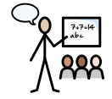 | At St Luke’s, all the teachers and helpers are trained to support kids who need extra help with learning or other things. They know how to make school a good place for everyone.  - Everyone who works at the school learns about keeping children safe and how to help kids learn better.  - Many staff have special training to help children with things like autism, ADHD, hearing or sight problems, speech difficulties, and learning challenges like dyslexia.  - Some staff are trained to help with feelings and emotions using special activities like Lego Therapy or talking sessions.  - They also know how to support children with medical needs or who need help managing their behavior.  - When a new child joins the school, staff work with the child’s old school and experts to make sure they get the right help from the start.  - Teachers keep learning new ways to support children by attending special meetings and getting advice from experts.  This way, St Luke’s makes sure every child gets the help they need to do their best and feel happy at school.
How will my child be included in activities outside the setting including trips and residential visits?   | At St Luke’s, we make sure every child can join in on fun activities like school trips and overnight stays, no matter what kind of help they might need.  - We plan trips so that all kids can take part, making changes to help with things like health, feelings, or how their body works.  - Sometimes, a child might have extra help from a grown-up, special transport, or different activities so they can be safe and comfortable.  - We talk with parents before trips to make sure everyone knows how to help the child and keep them safe.  - The adults who go on trips with the kids know a lot about how to support children with special needs and are trained to keep them safe.  At St Luke’s, we want everyone to have fun and feel included on all school adventures!
How accessible is the setting environment?   | At St Luke’s, we make sure the school is easy for every child to use and enjoy, no matter what help they might need.  - The school is all on one floor, so everyone can get around easily, even if they use a wheelchair.  - We have special things like quiet spaces and easy-to-see classrooms to help kids who are sensitive to noise or light.  - For kids who find talking or understanding hard, we use pictures and simple words to help them.  - If a family speaks another language, we try to find someone who can help translate so everyone understands.  - We always check and improve the school to make sure it stays welcoming and easy for everyone to learn and have fun.  At St Luke’s, everyone can feel safe, included, and ready to do their best!
How will the setting prepare and support my child moving to the next stage of education? How will you increase their independence?   | At St Luke’s, we know that moving from one school stage to another can be tricky, especially for children who need extra help. So, we make sure to help kids feel ready and confident.  - Our school has two parts close together, and teachers help kids move between them easily.  - When it’s time to go to secondary school, we work with those schools to help kids get used to the new place.  - Kids get to visit the new school with someone they know and meet their new teachers at St Luke’s.  - We use photo books and stories to help kids remember what to expect.  - We teach kids to understand what they’re good at and what they need help with.  - Kids learn to take part in meetings about their learning and practice new skills.  - We work with families and the next school so that support continues and kids feel ready and independent.  At St Luke’s, we help every child feel prepared and confident to take the next step in their learning journey!
How are the school's resources allocated and matched to children's SEND?   | At St Luke’s, we use money and resources carefully to help children who need extra support.  - The school gets money for all the kids to help with teaching and support.  - Kids with special needs get extra money to give them the help they need.  - Some children have special plans called EHC plans, and the school gets more money to give them extra support.  - We use things like extra helpers, special tools, and programs that match each child’s needs.  - The plans for kids with special needs are checked every year to make sure they’re still getting the right help.  - The SENDCo (the special needs leader) works with teachers to make sure support is given when and where it’s needed.  - We also work with experts outside the school to give the best support possible.  At St Luke’s, we make sure all children get the help they need to do their best!
How is the decision made about what type and how much support my child will receive?   | At St Luke’s, we work together to decide how to best help kids with special needs.  - The teacher and the SENDCo (the special needs helper) look at lots of information, like how the child is doing in school and advice from experts.  - They decide what kind of help the child needs to learn better and keep up with others.  - This plan is written down in a special book called a Individual Support Plan (ISP). It shows what the child needs help with, how teachers will help, and any extra support the child will get.  - Everyone who works with the child knows the plan and uses it to help the child in the best way.  - The SENDCo checks to make sure the support is working well.  - Parents are always told what’s happening and can share their ideas too.  - The goal is to give the right help so the child feels confident and can learn and grow just like their friends.  At St Luke’s, we make sure each child gets the help they need and keep checking that it’s working well!
How can I be involved? | At St Luke’s, we think it’s really important that parents and carers work with the school to help children learn and grow.  - Parents can help out by volunteering to read with kids, help on trips, or join in activities like walking to the church.  - If parents want to help, they can talk to their child’s teacher or the school office.  - There is a group called the PTFA where parents can join to help raise money and plan fun events for the school.  - The school also offers help for parents through classes and workshops, and parents can contact the Family Support Worker if they want to learn more.  - Teachers and parents talk regularly to share ideas and work together to support children both at school and at home.  By working together, parents and school help children do their best

There is more information available in the Coastal Learning Partnership’s policy for Inclusion and SEND which is available on the CLP website: https://www.coastalpartnership.co.uk/special-educational-needs-and-disability-send/

The Local Offer for Bournemouth Local Authority can be found at: https://fid.bcpcouncil.gov.uk/send-local-offer
This provides information on services and activities for children and young people living in Bournemouth, Christchurch and Poole aged 0 to 25 with special educational needs and disabilities.

This report is due for review in September 2027

