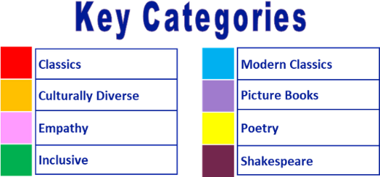
Year 2 reading spine – (core texts – love to read)

Autumn 1 |  |  |  |  |  |  |  | Autumn 2 |  |  |  |  |  |  |  | Spring 1 |  |  |  |  |  |  |  | Spring 2 |  |  |  |  |  |  |  | Summer 1 |  |  |  |  |  |  |  | Summer 2
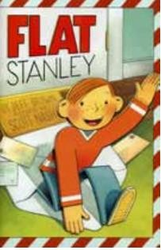 |  |  |  |  |  |  |  | 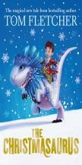 |  |  |  |  |  |  |  | 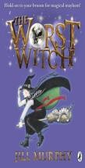 |  |  |  |  |  |  |  | 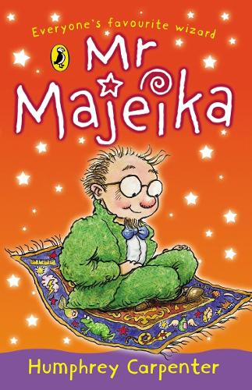 |  |  |  |  |  |  |  | 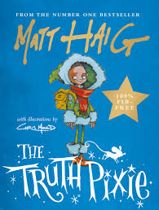 |  |  |  |  |  |  |  | 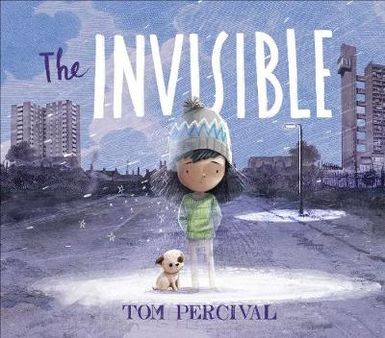
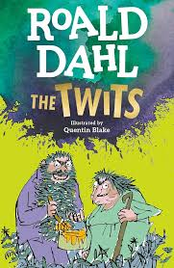 |  |  |  |  |  |  |  | 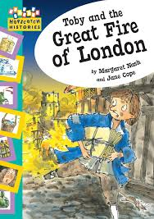 |  |  |  |  |  |  |  |  |  |  |  |  |  |  |  |  |  |  |  |  |  |  |  | 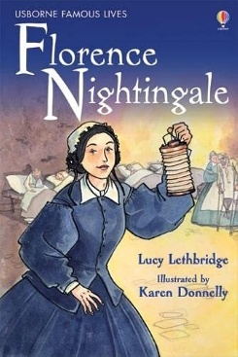 |  |  |  |  |  |  |  | 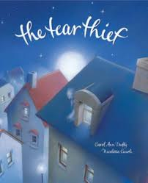

Year 2 reading spine – (key texts)

Autumn 1 |  |  |  |  |  |  |  | Autumn 2 |  |  |  |  |  |  |  | Spring 1 |  |  |  |  |  |  |  | Spring 2 |  |  |  |  |  |  |  | Summer 1 |  |  |  |  |  |  |  | Summer 2
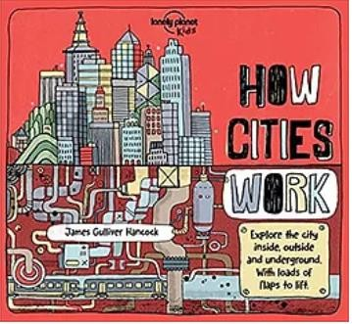 |  |  |  |  |  |  |  |  |  |  |  |  |  |  |  | 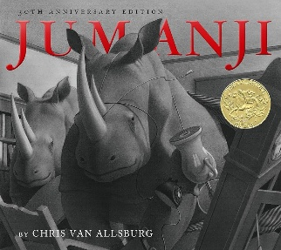 |  |  |  |  |  |  |  | 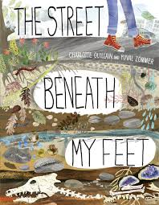 |  |  |  |  |  |  |  | 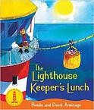 |  |  |  |  |  |  |  | 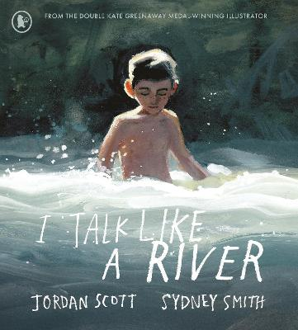
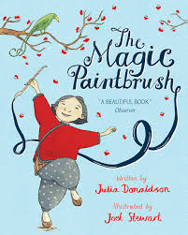 |  |  |  |  |  |  |  |  |  |  |  |  |  |  |  | 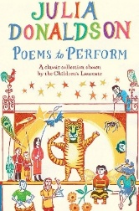 |  |  |  |  |  |  |  |  |  |  |  |  |  |  |  | 
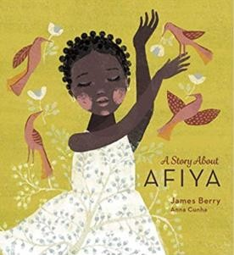
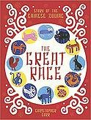
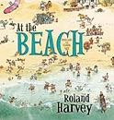
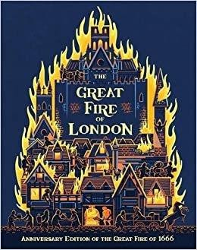
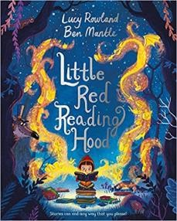
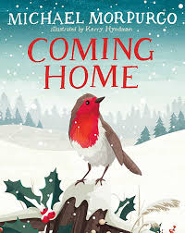
Suggested reads – quality texts available in the classroom:


