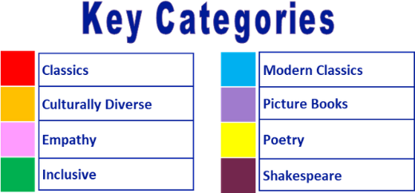
Year 3 reading spine – (core texts – love to read)

Autumn 1 |  |  |  |  |  |  |  | Autumn 2 |  |  |  |  |  |  |  | Spring 1 |  |  |  |  |  |  |  | Spring 2 |  |  |  |  |  |  |  | Summer 1 |  |  |  |  |  |  |  | Summer 2
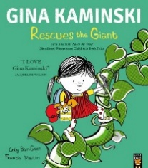  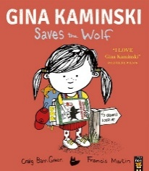 |  |  |  |  |  |  |  |  |  |  |  |  |  |  |  | 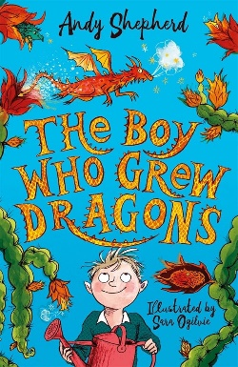 |  |  |  |  |  |  |  | 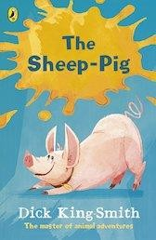  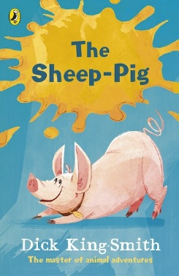 |  |  |  |  |  |  |  | 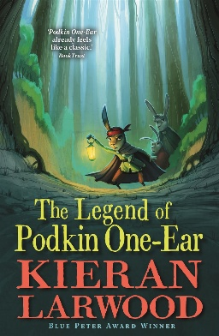 |  |  |  |  |  |  |  | 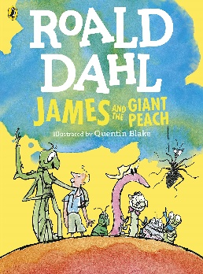
3 weeks


3 weeks |  |  |  |  |  |  |  | 5-6 weeks |  |  |  |  |  |  |  | 5-6 weeks |  |  |  |  |  |  |  | 5-6 weeks |  |  |  |  |  |  |  | 5-6 weeks |  |  |  |  |  |  |  | 5-6 weeks

Year 3 reading spine – (key texts)

Autumn 1 |  |  |  |  |  |  |  | Autumn 2 |  |  |  |  |  |  |  | Spring 1 |  |  |  |  |  |  |  | Spring 2 |  |  |  |  |  |  |  | Summer 1 |  |  |  |  |  |  |  | Summer 2
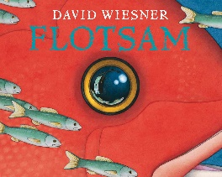 |  |  |  |  |  |  |  | 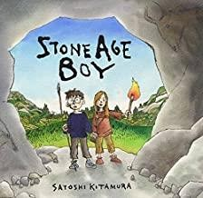 |  |  |  |  |  |  |  | 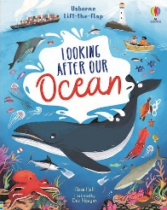 |  |  |  |  |  |  |  | 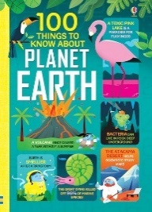 |  |  |  |  |  |  |  | 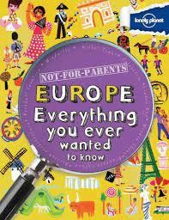 |  |  |  |  |  |  |  | 
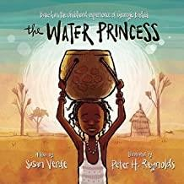 |  |  |  |  |  |  |  | 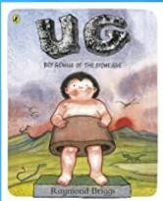
Shared books |  |  |  |  |  |  |  | Shared books |  |  |  |  |  |  |  | Shared books |  |  |  |  |  |  |  | Shared books |  |  |  |  |  |  |  | Shared books |  |  |  |  |  |  |  | Shared books
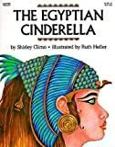
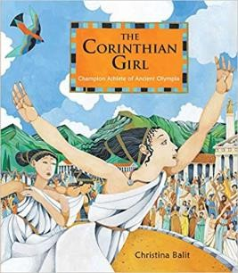
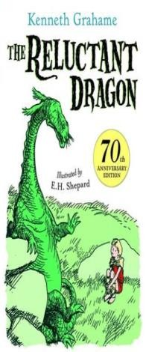
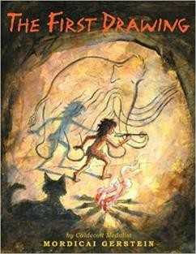
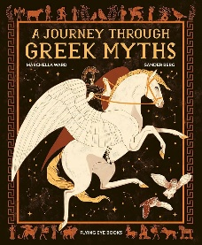
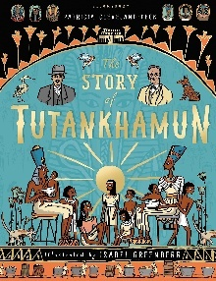
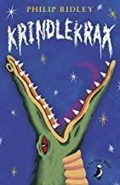
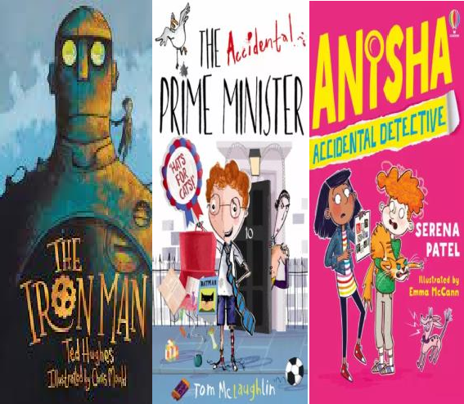
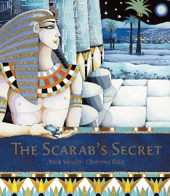
Suggested reads – quality texts available in the classroom:


