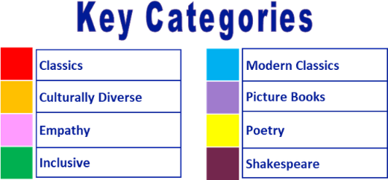
Year 4 reading spine – (core texts – love to read)

Autumn 1 |  |  |  |  |  |  |  | Autumn 2 |  |  |  |  |  |  |  | Spring 1 |  |  |  |  |  |  |  | Spring 2 |  |  |  |  |  |  |  | Summer 1 |  |  |  |  |  |  |  | Summer 2
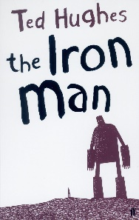 |  |  |  |  |  |  |  | 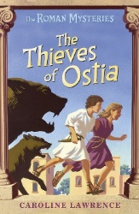 |  |  |  |  |  |  |  | 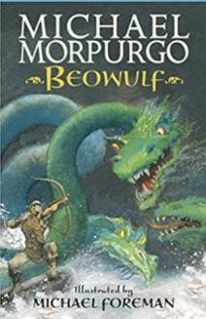 |  |  |  |  |  |  |  | 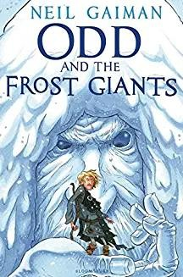 |  |  |  |  |  |  |  | 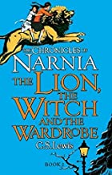 |  |  |  |  |  |  |  | 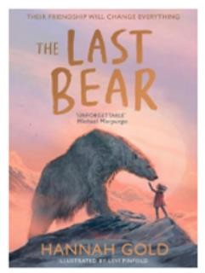
3 weeks
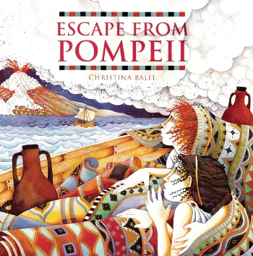
2 weeks |  |  |  |  |  |  |  | 3 weeks |  |  |  |  |  |  |  | 4 weeks |  |  |  |  |  |  |  | 3 weeks |  |  |  |  |  |  |  | 4 weeks |  |  |  |  |  |  |  | 4-5 weeks

Year 4 reading spine – (key texts)

Autumn 1 |  |  |  |  |  |  |  | Autumn 2 |  |  |  |  |  |  |  | Spring 1 |  |  |  |  |  |  |  | Spring 2 |  |  |  |  |  |  |  | Summer 1 |  |  |  |  |  |  |  | Summer 2
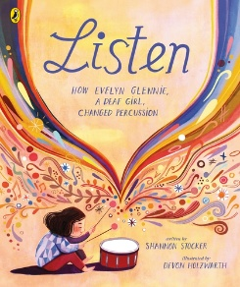 |  |  |  |  |  |  |  | 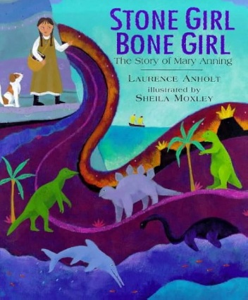 |  |  |  |  |  |  |  | 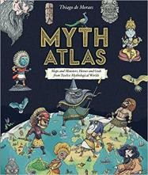 |  |  |  |  |  |  |  | 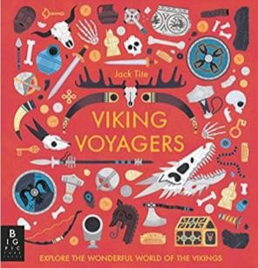 |  |  |  |  |  |  |  | 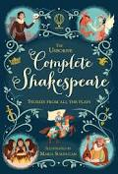  A Midsummer Night’s Dream |  |  |  |  |  |  |  | Poetry  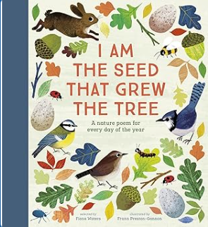
2 weeks |  |  |  |  |  |  |  | 3 weeks |  |  |  |  |  |  |  | 2 weeks |  |  |  |  |  |  |  | 3 weeks |  |  |  |  |  |  |  | 2 weeks |  |  |  |  |  |  |  | 2 weeks
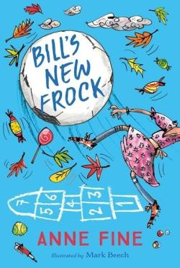
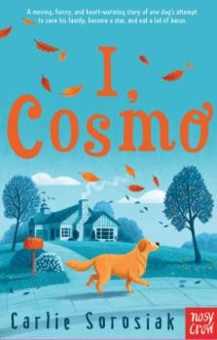
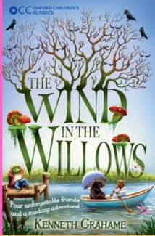
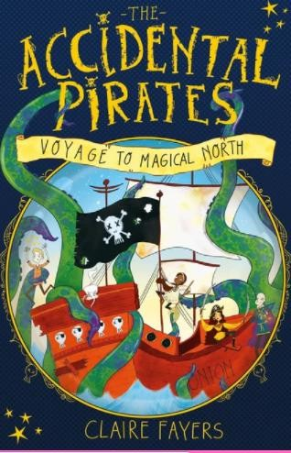
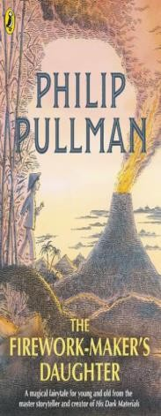
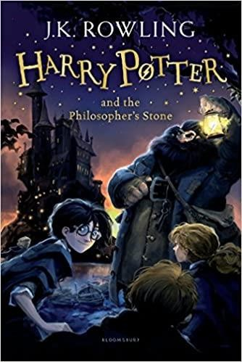
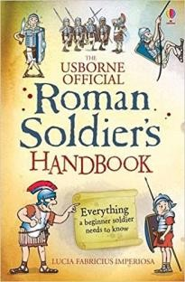
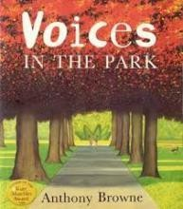
Suggested reads – quality texts available in the classroom:


