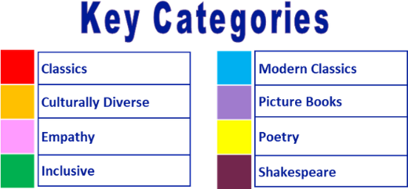
Year 5 reading spine – (core texts – love to read)

Autumn 1 |  |  |  |  |  |  |  | Autumn 2 |  |  |  |  |  |  |  | Spring 1 |  |  |  |  |  |  |  | Spring 2 |  |  |  |  |  |  |  | Summer 1 |  |  |  |  |  |  |  | Summer 2
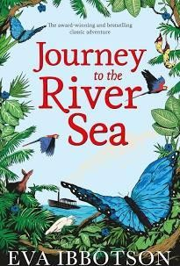 |  |  |  |  |  |  |  | 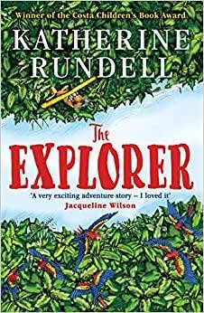 |  |  |  |  |  |  |  | 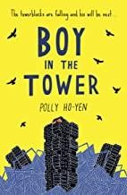 |  |  |  |  |  |  |  | 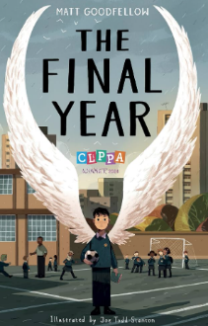 |  |  |  |  |  |  |  | 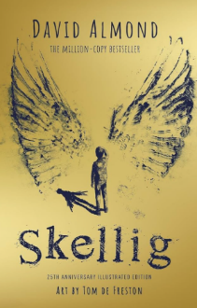 |  |  |  |  |  |  |  | 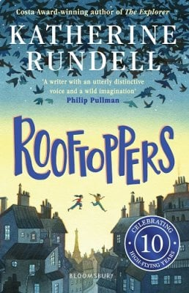
5 weeks |  |  |  |  |  |  |  | 6 weeks |  |  |  |  |  |  |  | 6 weeks |  |  |  |  |  |  |  | 6 weeks |  |  |  |  |  |  |  | 5 weeks |  |  |  |  |  |  |  | 4-5 weeks

Year 5 reading spine – (key texts)

Autumn 1 |  |  |  |  |  |  |  | Autumn 2 |  |  |  |  |  |  |  | Spring 1 |  |  |  |  |  |  |  | Spring 2 |  |  |  |  |  |  |  | Summer 1 |  |  |  |  |  |  |  | Summer 2
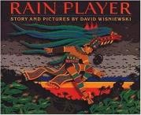 |  |  |  |  |  |  |  | 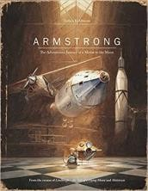 |  |  |  |  |  |  |  |  |  |  |  |  |  |  |  | 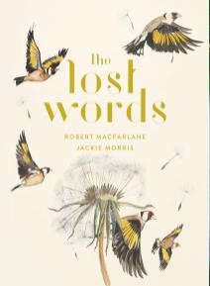 |  |  |  |  |  |  |  | 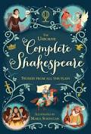  Hamlet |  |  |  |  |  |  |  | Lovereading4Kids  
1 week |  |  |  |  |  |  |  | 1 week |  |  |  |  |  |  |  |  |  |  |  |  |  |  |  | 1 week |  |  |  |  |  |  |  | 1 week |  |  |  |  |  |  |  | 2 weeks
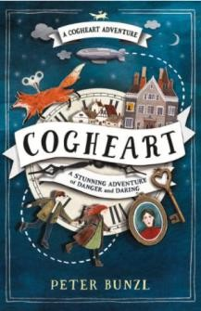
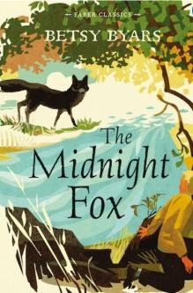

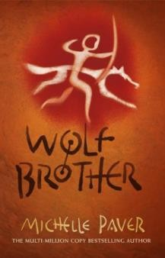

Suggested reads – quality texts available in the classroom:


