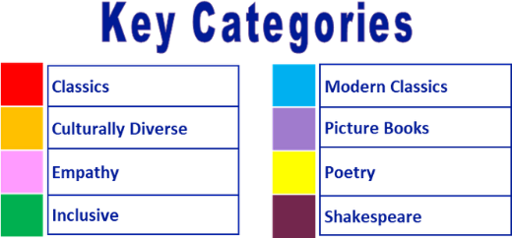
Year 6 reading spine – (core texts – love to read)

Autumn 1 |  |  |  |  |  |  |  | Autumn 2 |  |  |  |  |  |  |  | Spring 1 |  |  |  |  |  |  |  | Spring 2 |  |  |  |  |  |  |  | Summer 1 |  |  |  |  |  |  |  | Summer 2
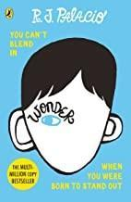 |  |  |  |  |  |  |  | 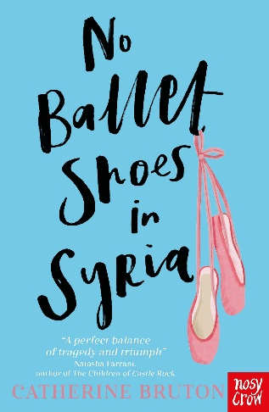 |  |  |  |  |  |  |  | 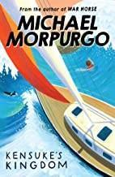 |  |  |  |  |  |  |  | 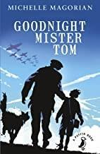 |  |  |  |  |  |  |  | 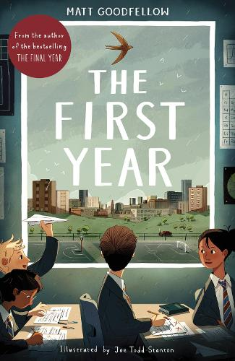 |  |  |  |  |  |  |  | 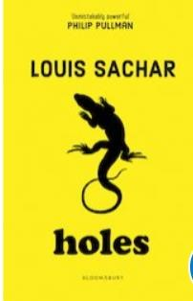
6-7 weeks |  |  |  |  |  |  |  | 4-5 weeks |  |  |  |  |  |  |  | 6-7 weeks |  |  |  |  |  |  |  | 6-7 weeks |  |  |  |  |  |  |  | 6-7 weeks |  |  |  |  |  |  |  | 4-5 weeks

Year 6 reading spine – (key texts)

Autumn 1 |  |  |  |  |  |  |  | Autumn 2 |  |  |  |  |  |  |  | Spring 1 |  |  |  |  |  |  |  | Spring 2 |  |  |  |  |  |  |  | Summer 1 |  |  |  |  |  |  |  | Summer 2
 |  |  |  |  |  |  |  | 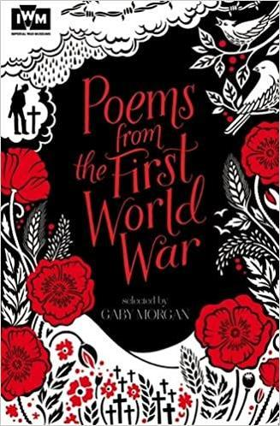 |  |  |  |  |  |  |  | 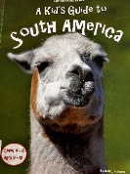 |  |  |  |  |  |  |  |  |  |  |  |  |  |  |  | 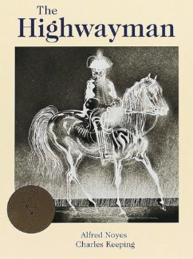 |  |  |  |  |  |  |  | 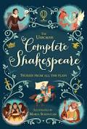  Romeo and Juliet
 |  |  |  |  |  |  |  | 2 weeks |  |  |  |  |  |  |  | 2 weeks |  |  |  |  |  |  |  |  |  |  |  |  |  |  |  | 1 week |  |  |  |  |  |  |  | 2 weeks

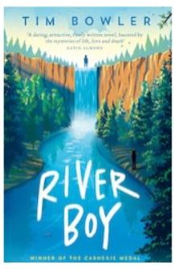
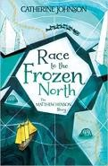
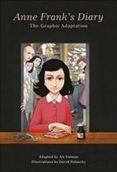
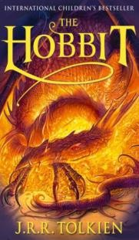
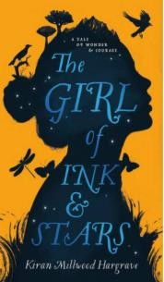
Suggested reads – quality texts available in the classroom:



